**Git**

Git is a free and open source distributed version control system designed to handle everything from small to very large projects with speed and efficiency.

Imagine if we are building an applications and the change we made,makes our application crashed and we want the history of the applicationso that the last right code would be implemented.

Git allows us to maintain history of application,which person makes which changes by which time.

It allows us the people to contribute in our program

Git hub is a platform or website that allows us to host our repositories(folder where all changes are saved).

Source code management (**SCM**) is used to track modifications to a source code repository.

* Aprill 2005
* Created by Linus Torvalds
* Replacement of Bit Keeper to manage Linux Kernel Source Code.
* Open Source And free
* Distributed VCS
* Faster than other SCMs
* Compatible with Linux,Windows and macOS.

Git commands:

Globally Configuration

Git config –global user.name “Kashish”

Git config –global user.email “[kashu@gmail.com](mailto:kashu@gmail.com)”

Git config –list

Git init →Initialize git.

Ls la→Shows All hidden Files

Git checkout _→ shows the changes of last commit

Touch index.html →It means touch command creates file.

Git checkout -f → shows the changes of last commit of all files.

Git log -p -1 → shows the data of last 1 commit.

Git add→ It adds the file to staging area.

Git add -a→ It adds all the files to staging area.

Git diff →It compares the staging area and working tree is same.

Git commit -a -m “Added”-->It commits the change with a message.

Git log→Shows all recent commits.

Ls→shows list of files in currrent directory.

Git rm –cached→It removes the file from staging area but not from hard disk.

Git rm → removes the file from everywhere

.gitignore→Files inside .gitignore folder are untracked files.

If added slash then they are untracked from everywhere.

Git branch f1→ it creates branch which can be changed and changes not reflected in main branch.

Git checkout master → directly switch to master.

Git checkout f1 → switch to f1 branch.

Git merge f1→ it merges the f1 to master. Changes are made to master.

Git checkout -b f2→It makes new branch and switched to f2.

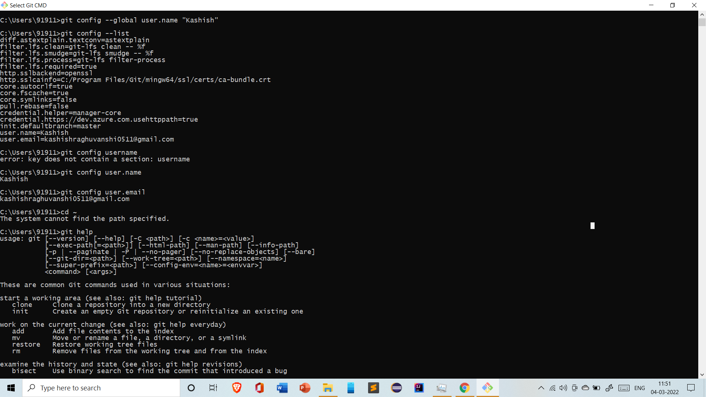

By Using git config user.name → gives name. z

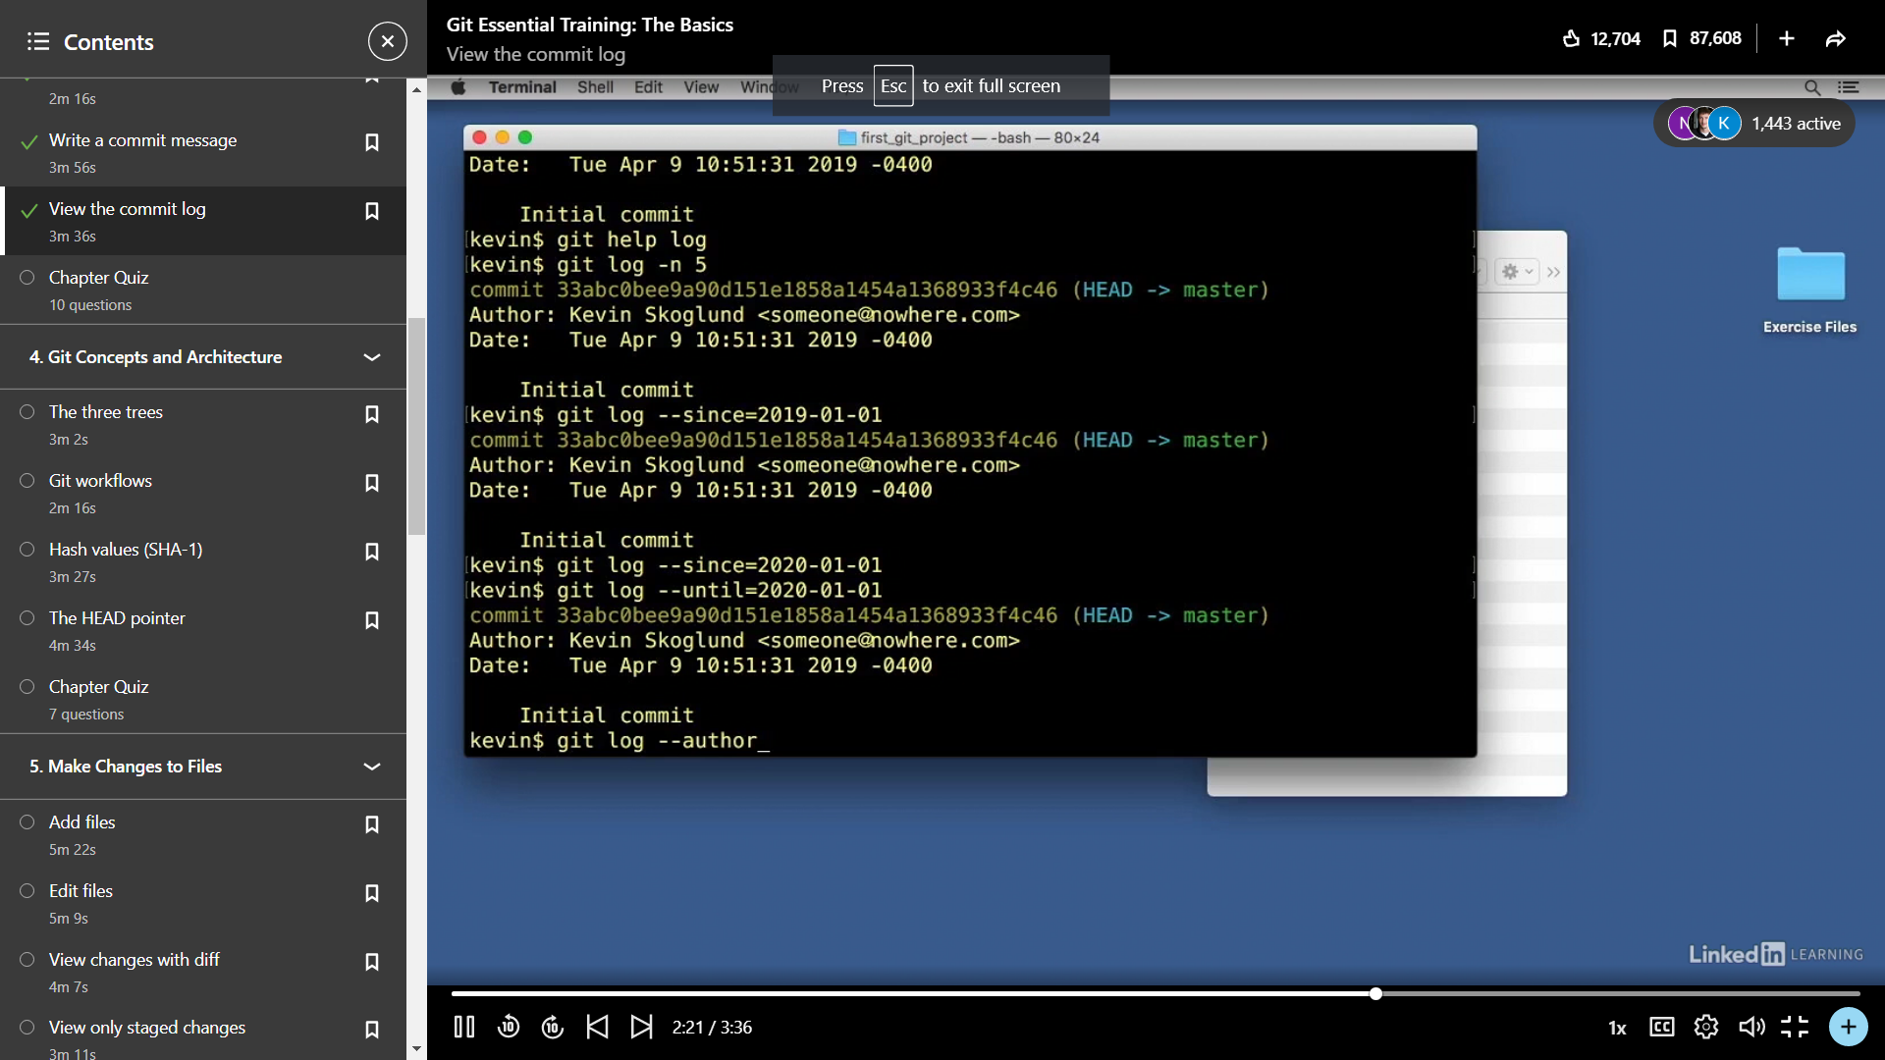git help →Gives instructions of all commands.

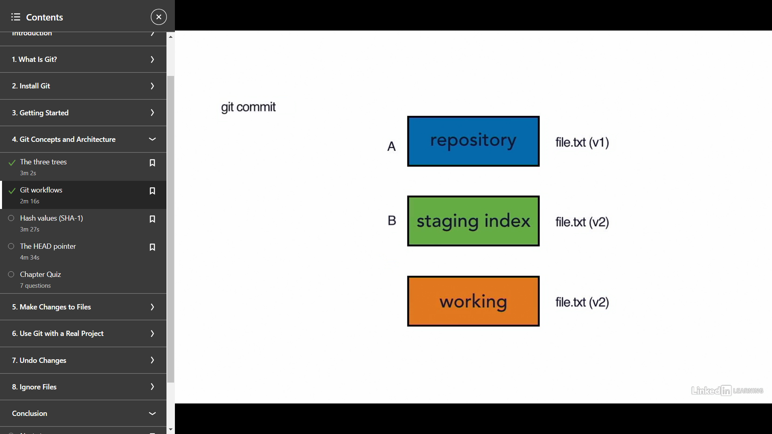

There are 3 types of stages:

Repository,Staging index and working area.

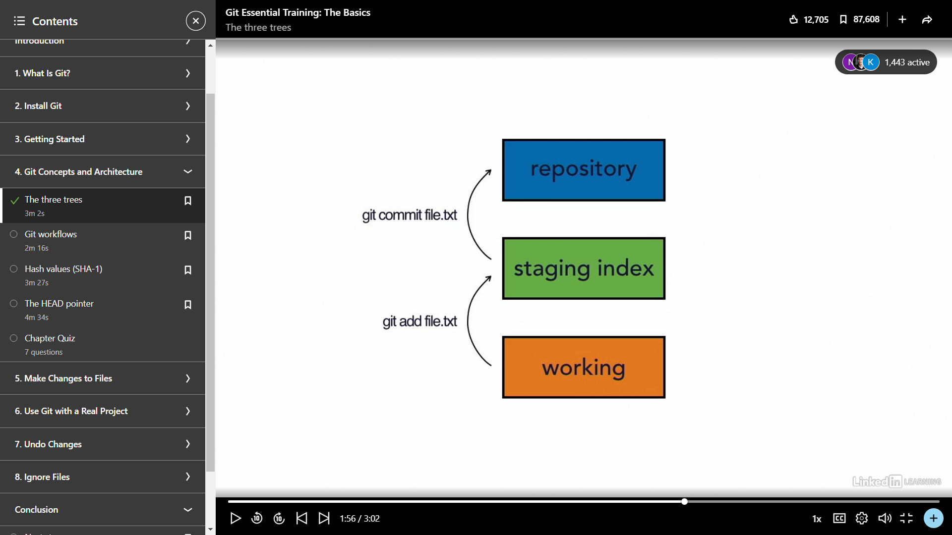

It adds file by using (git add) to staging index and commits to repository by using (git commit).

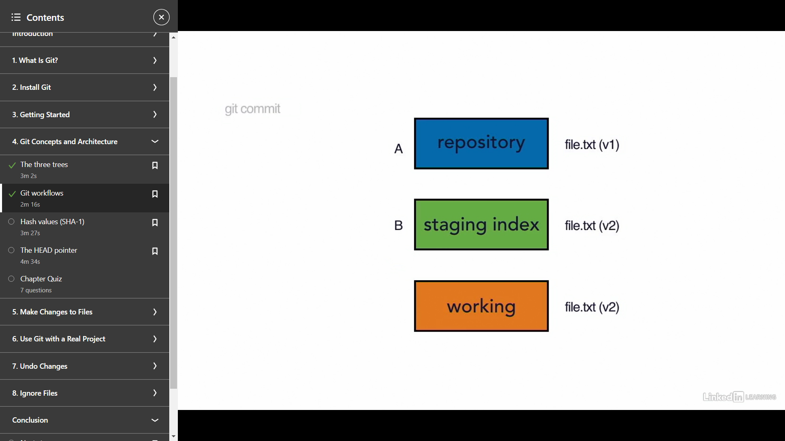

Firstly, A gets added to staging index and then commits to repository.



Then B does the same.

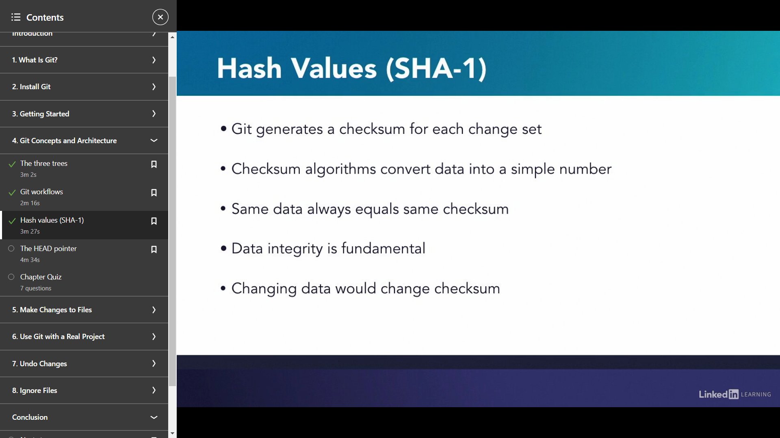

*SHA-1 (Secure Hash Algorithm 1) is a cryptographic hash function that takes an input and produces a 160-bit (20-byte) hash value known as a message digest – typically rendered as a hexadecimal number, 40 digits long.*

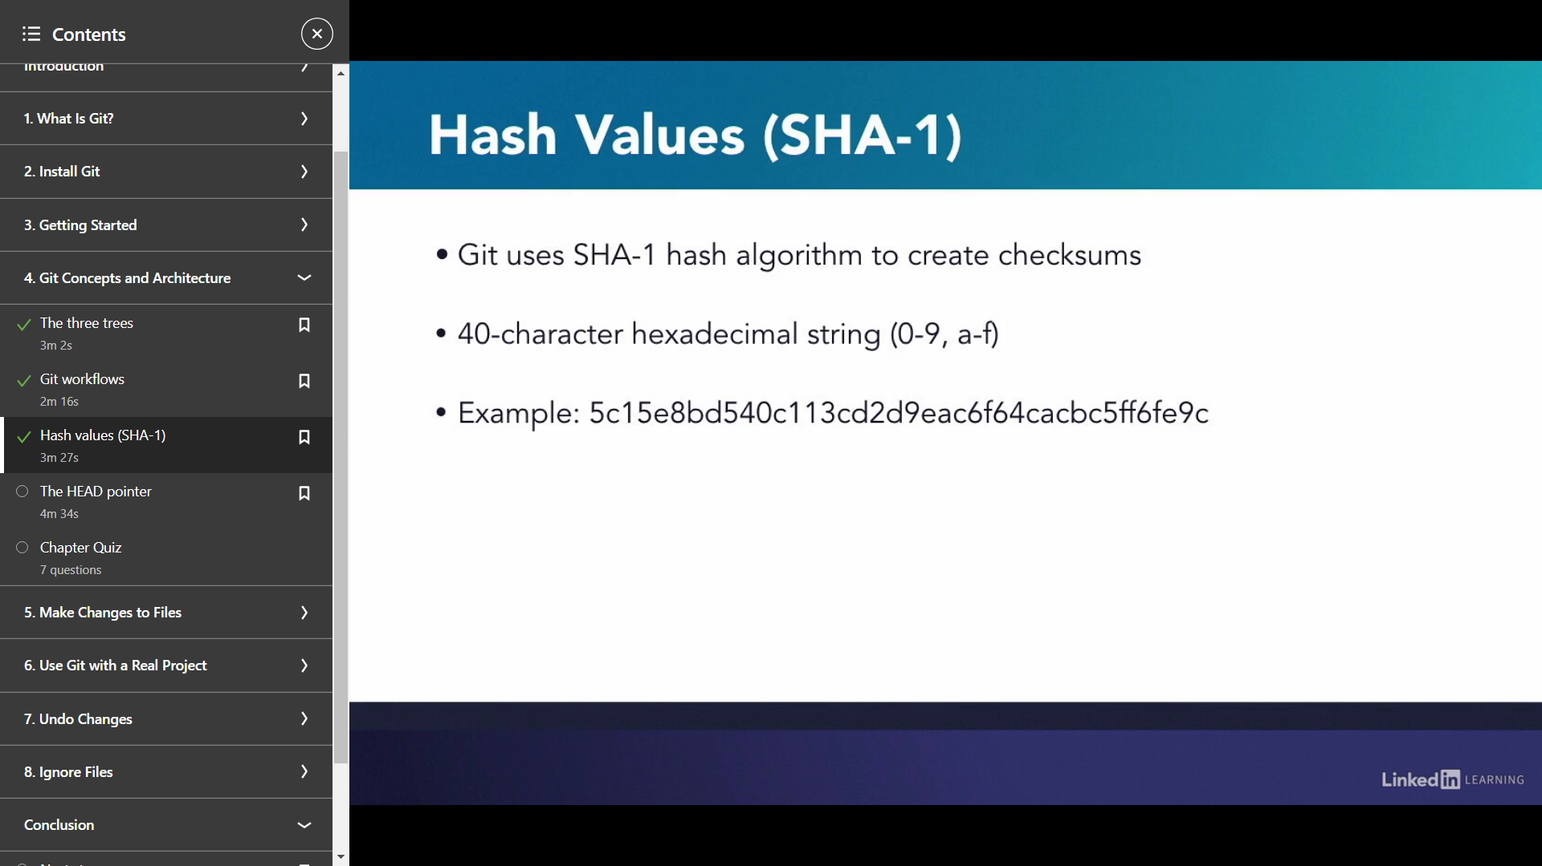

A checksum is a simple number that’s created by taking data and feeding it into a mathematical algorithm.

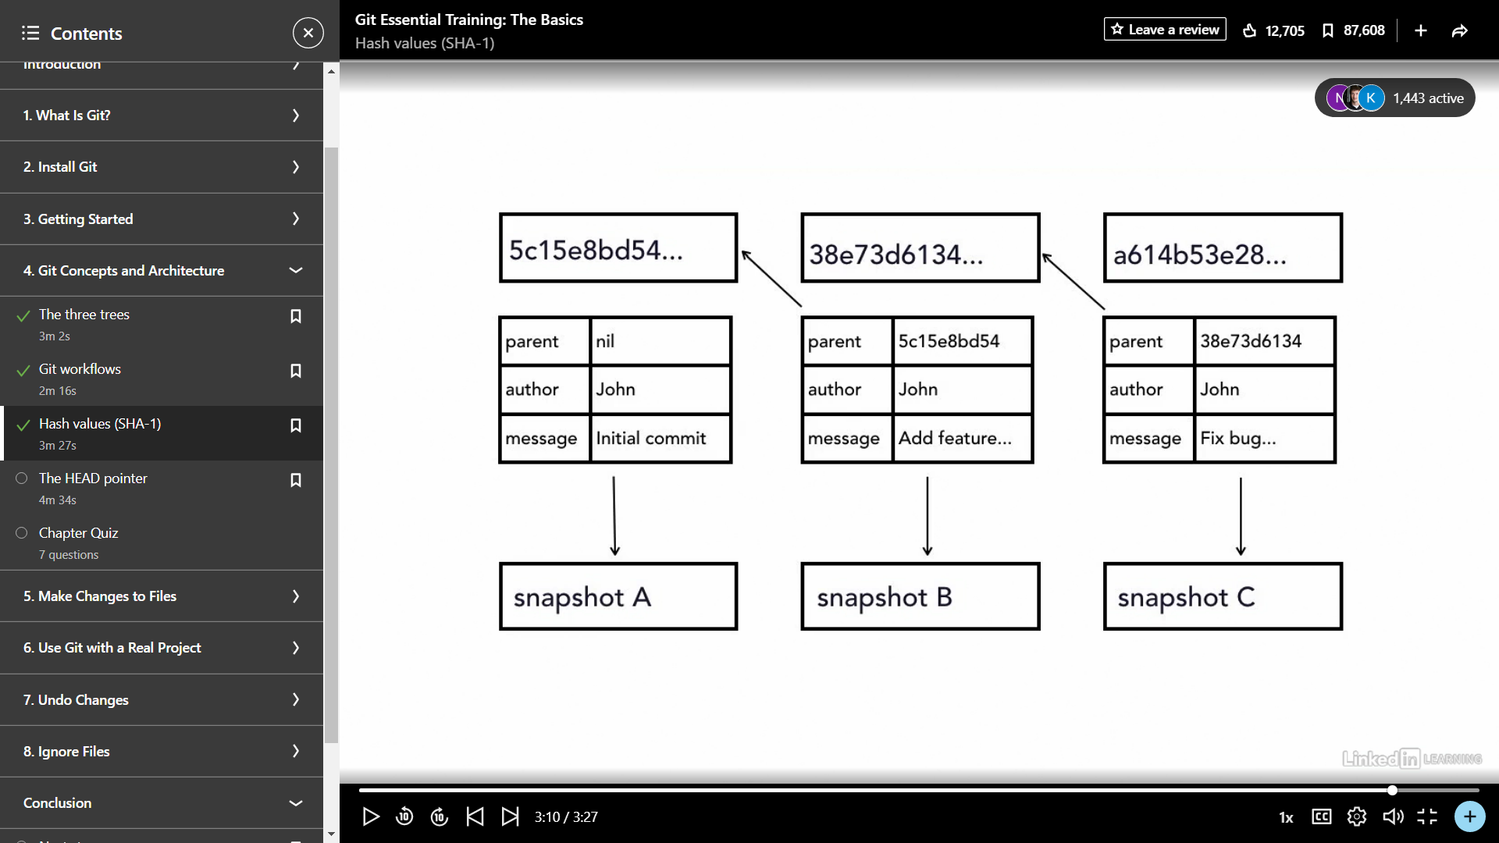

A snapshot A is connected with snapshot B and B to C by Hash Values generated.

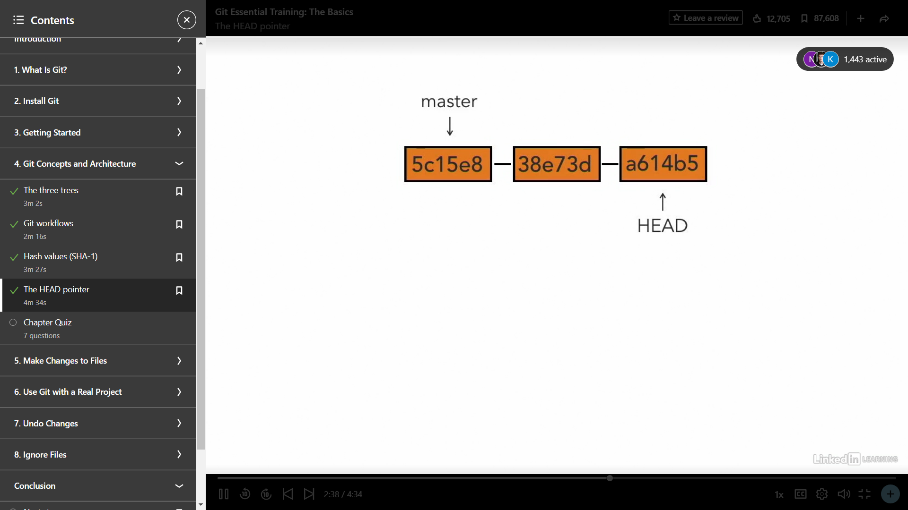

When they are connected to each other by linking each other through hash values So,master is the first commit and the changes we make generates the new hashvalue and HEAD points towards this.

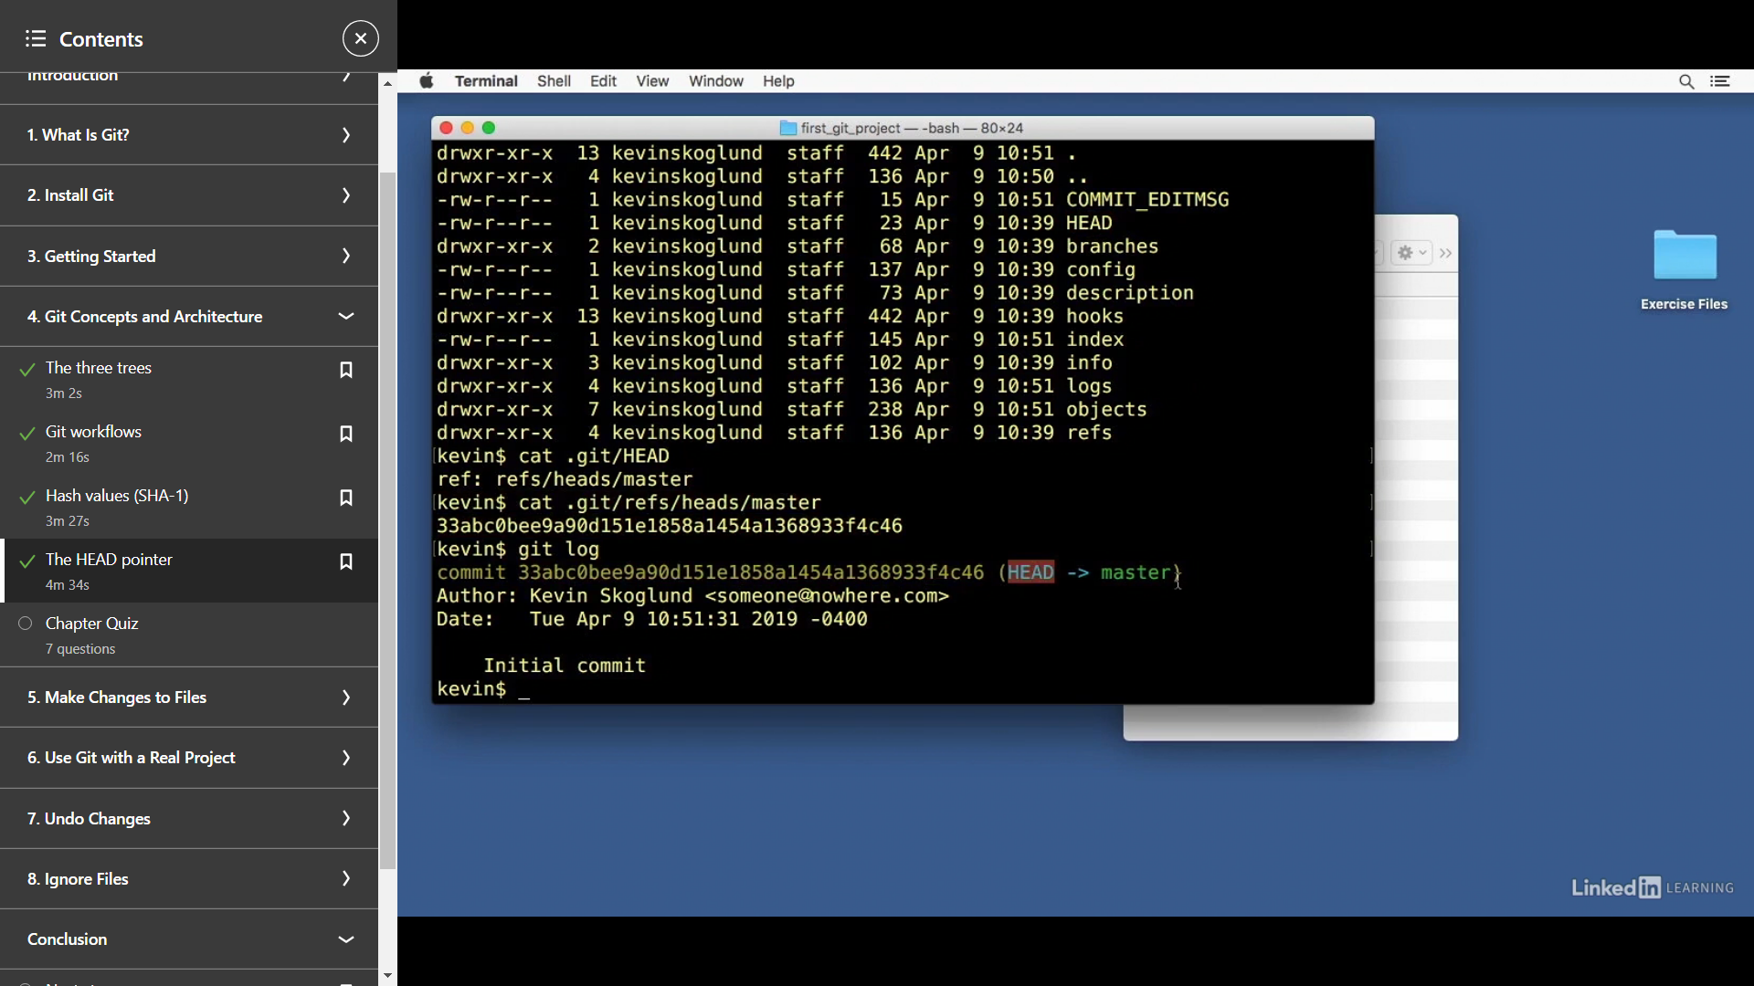

By using cat .git/HEAD →It gives reference to which snapshot the head is pointing.

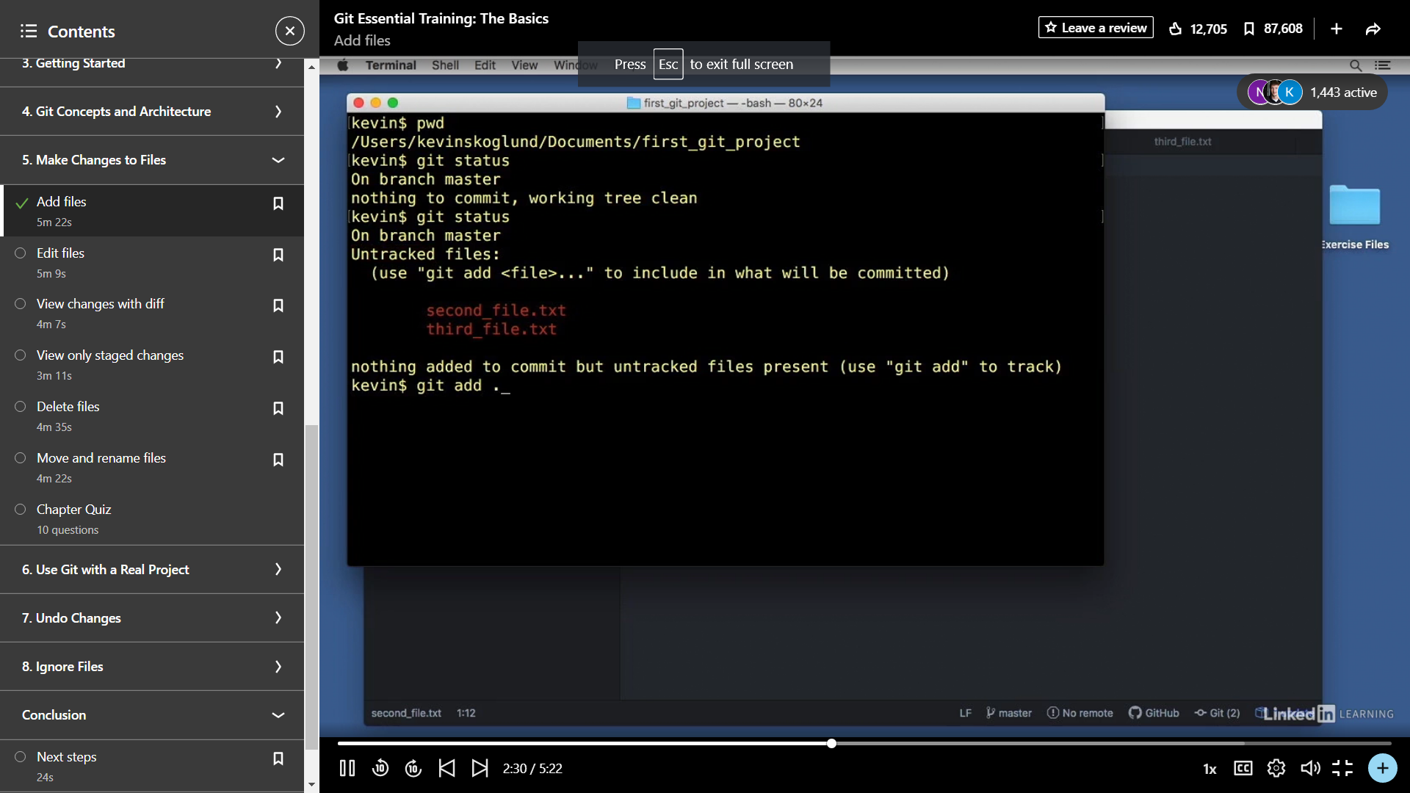

Git status→**displays the state of the working directory and the staging area**.

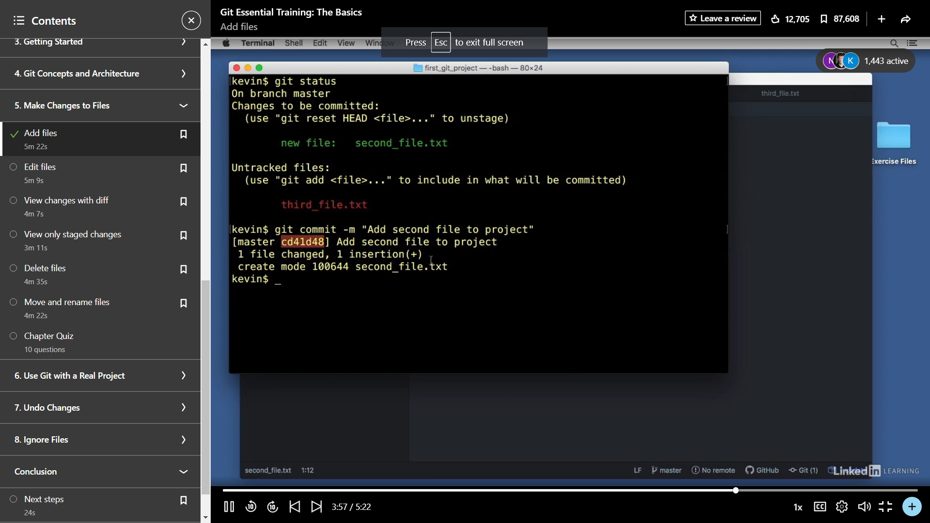

When the second_file.txt is added but not specified in the repository it moves to untracked files.The files are tracked in git repository.The changes we made i.e. adding,editing or modify any change in file,we have to add and commit the changes in repository.

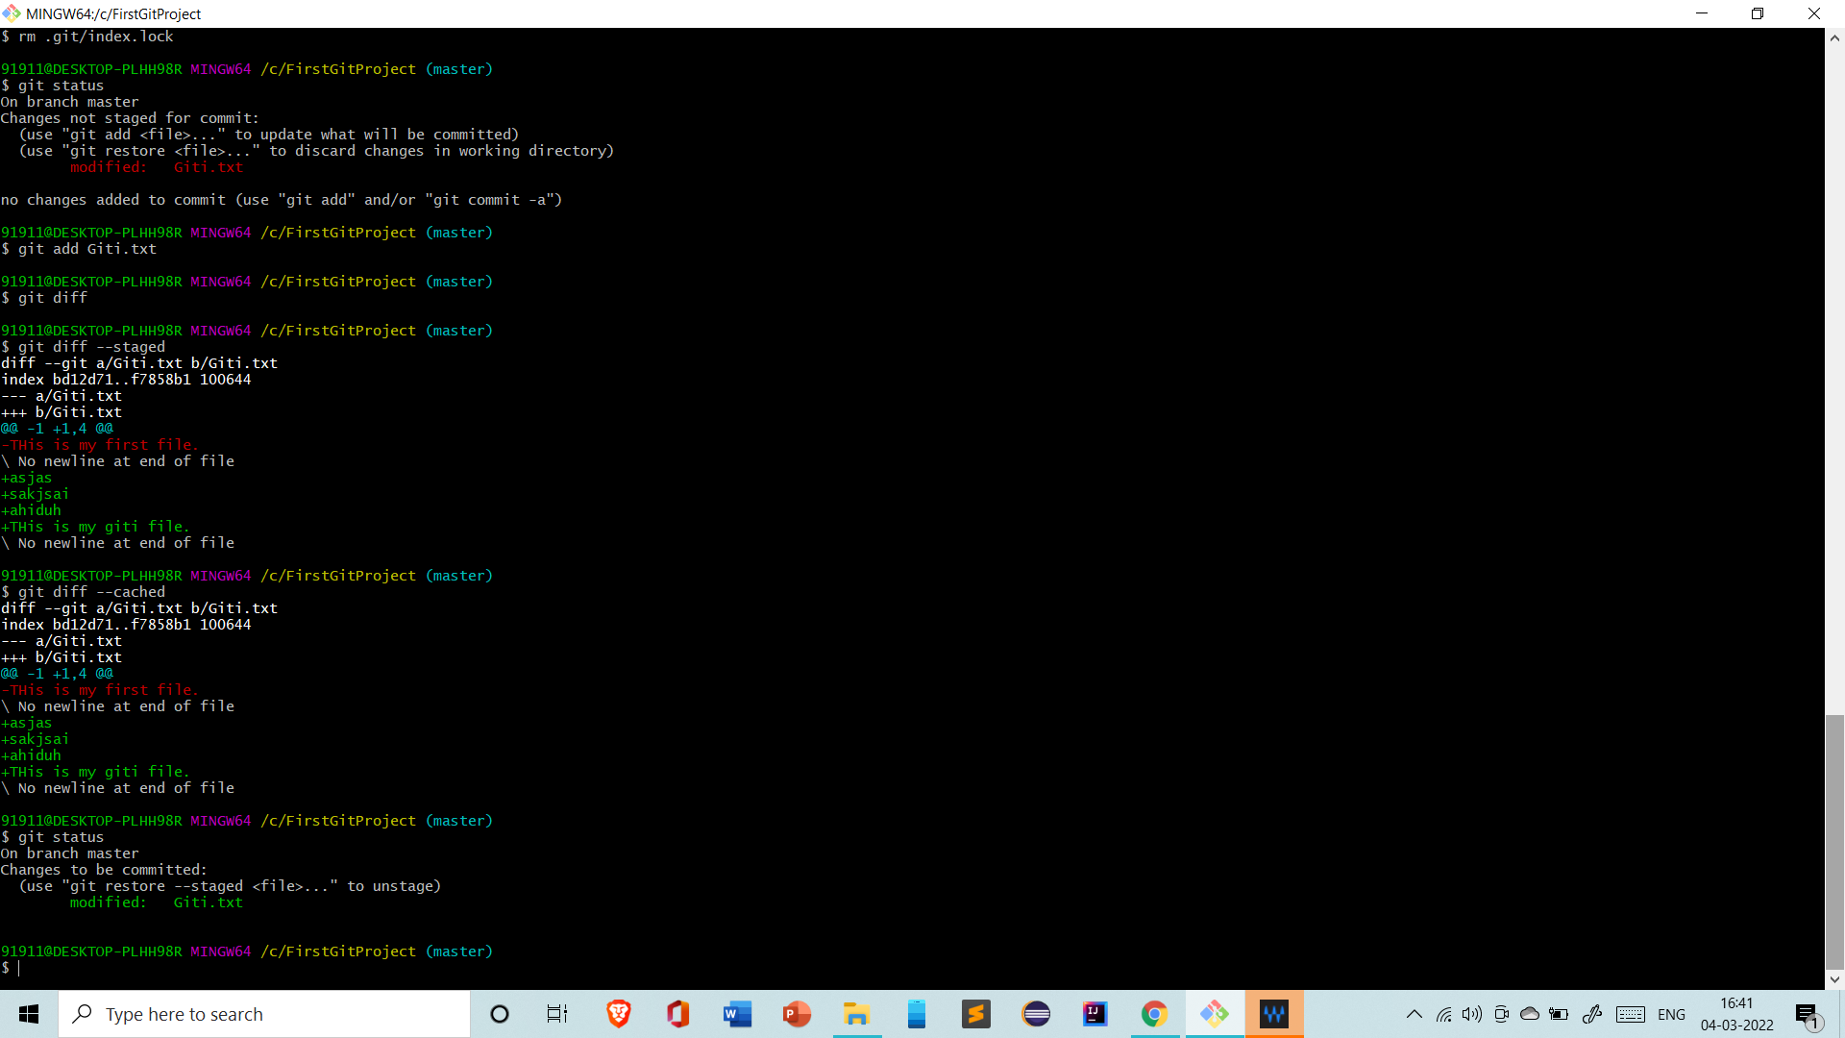

This is what I did to implement the things.

git add <file>

git commit -m "commit message"

Git –diff → show

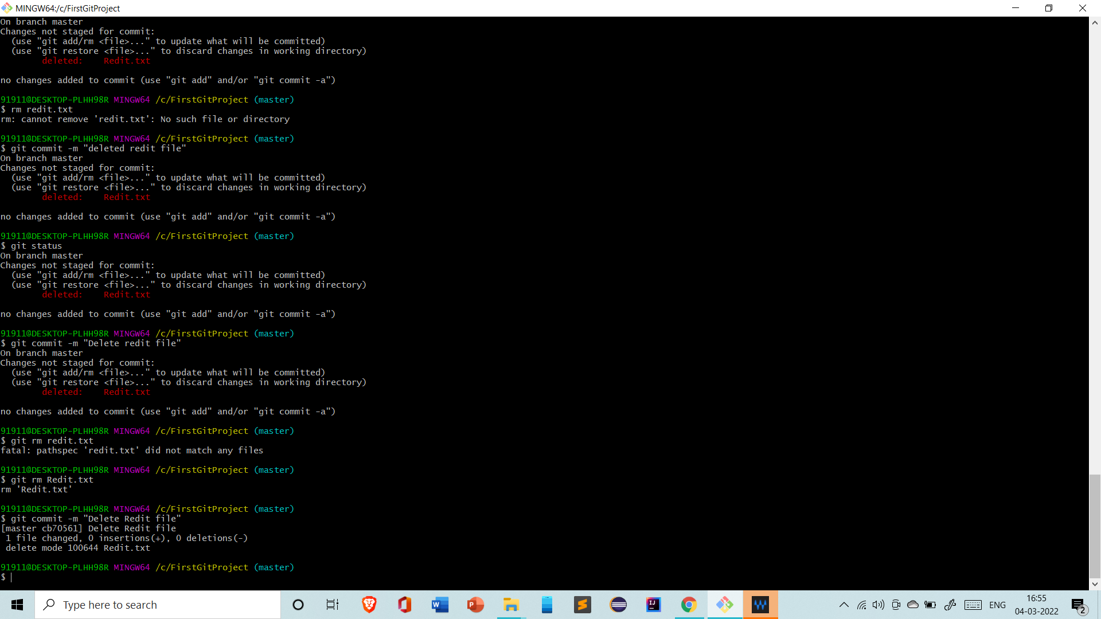

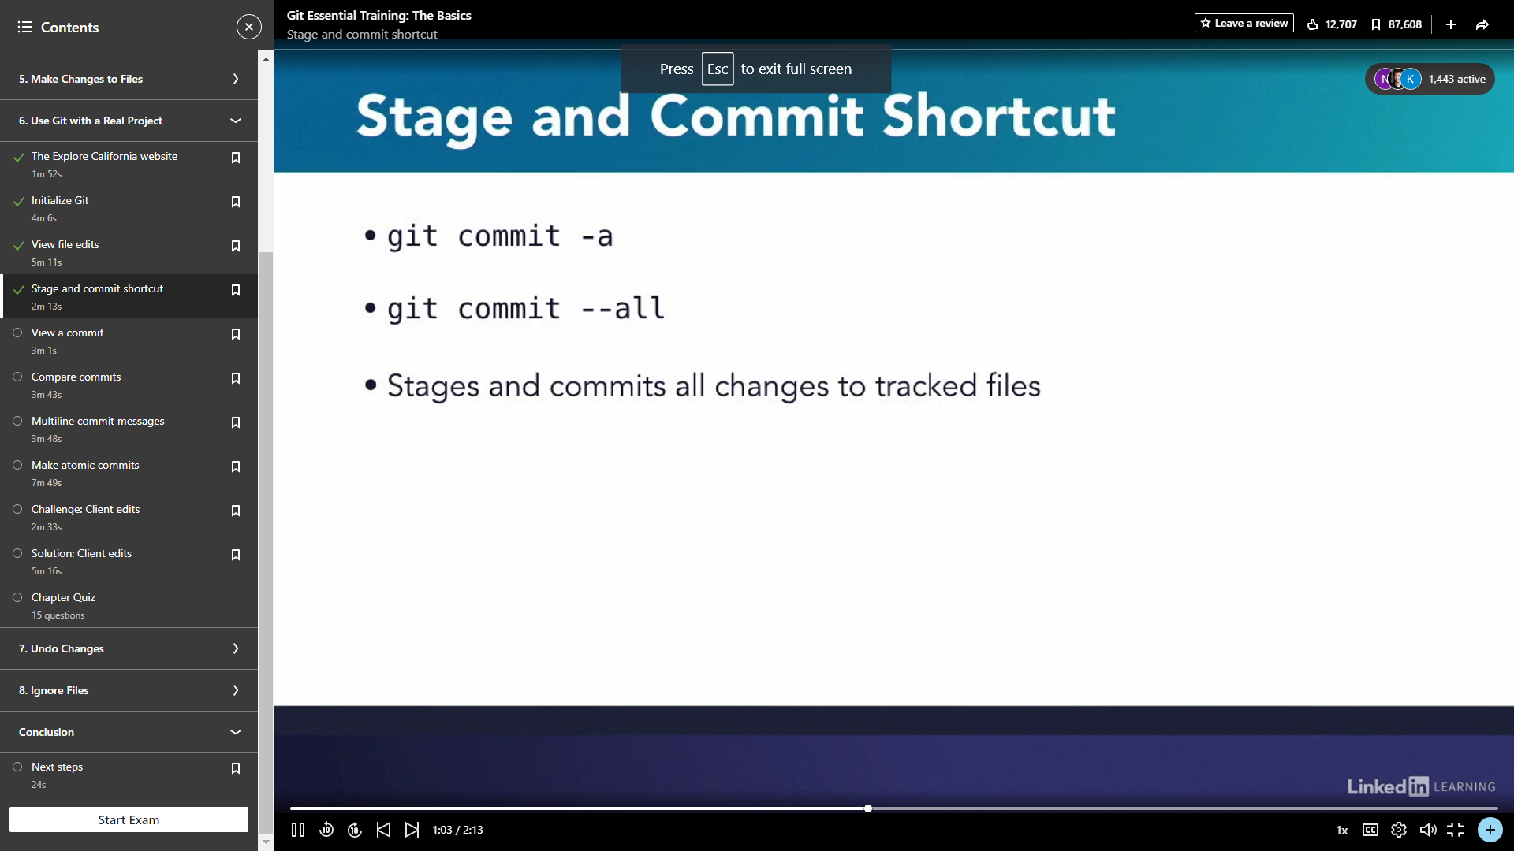

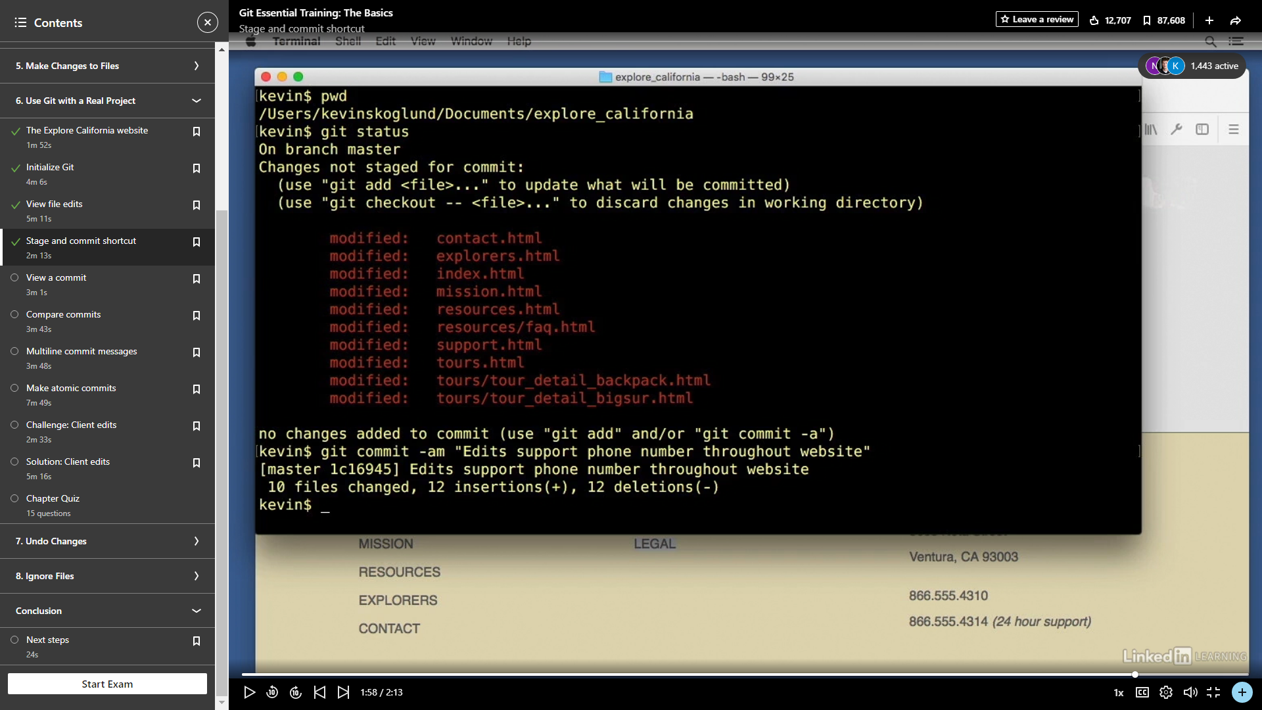

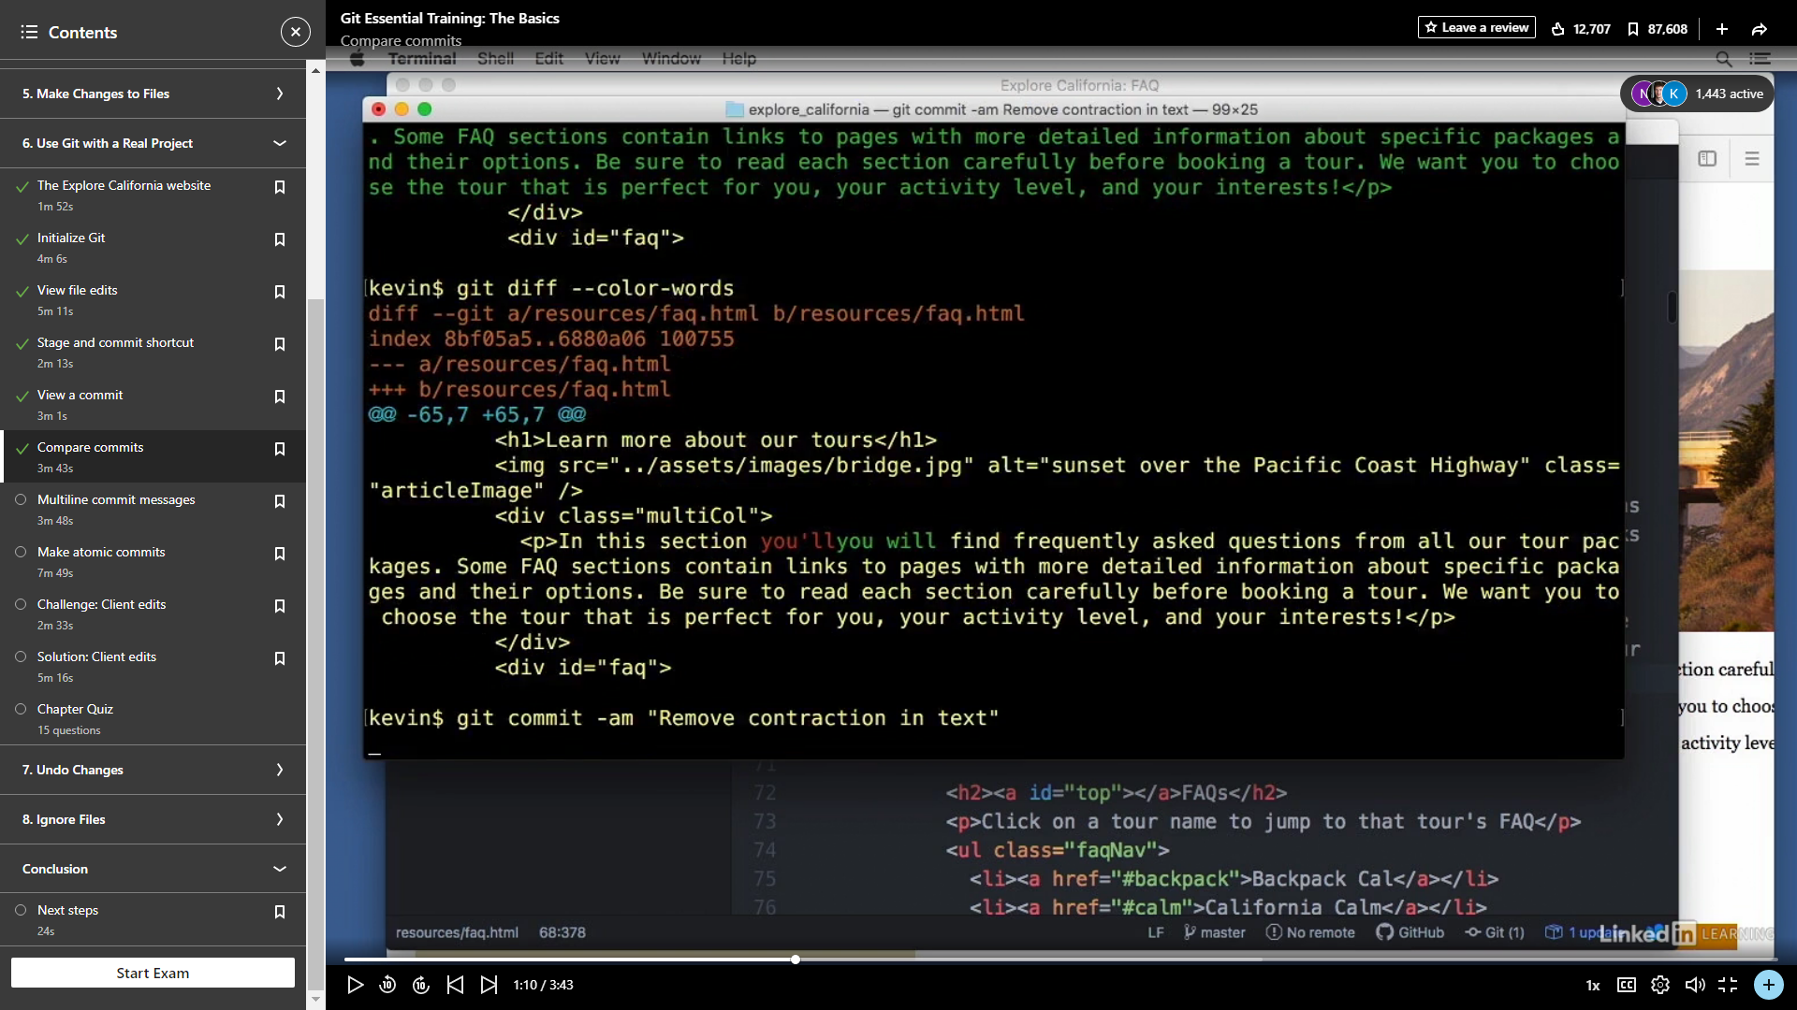

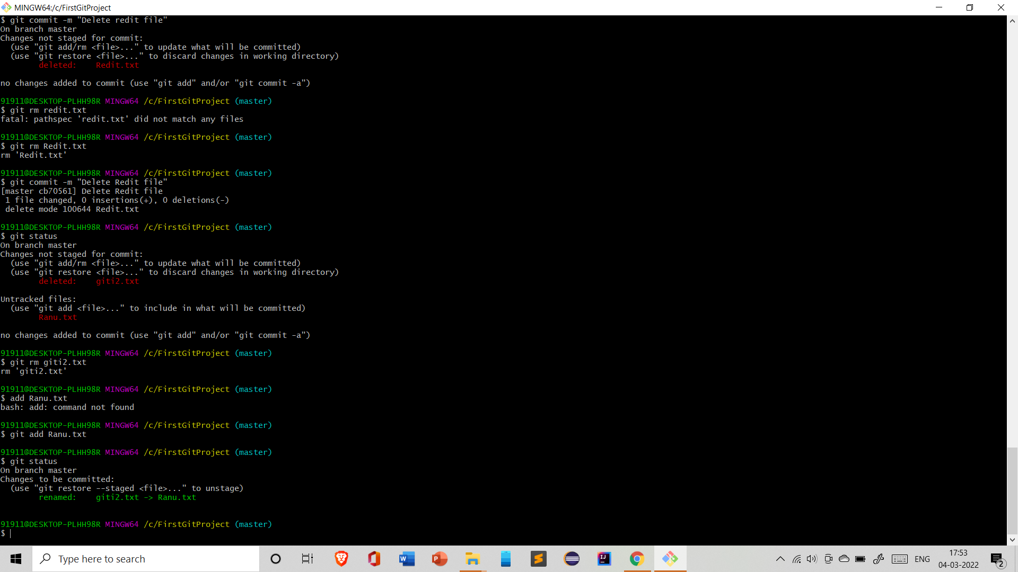

Here we can see the checkout command **lets you navigate between the branches created by git branch**

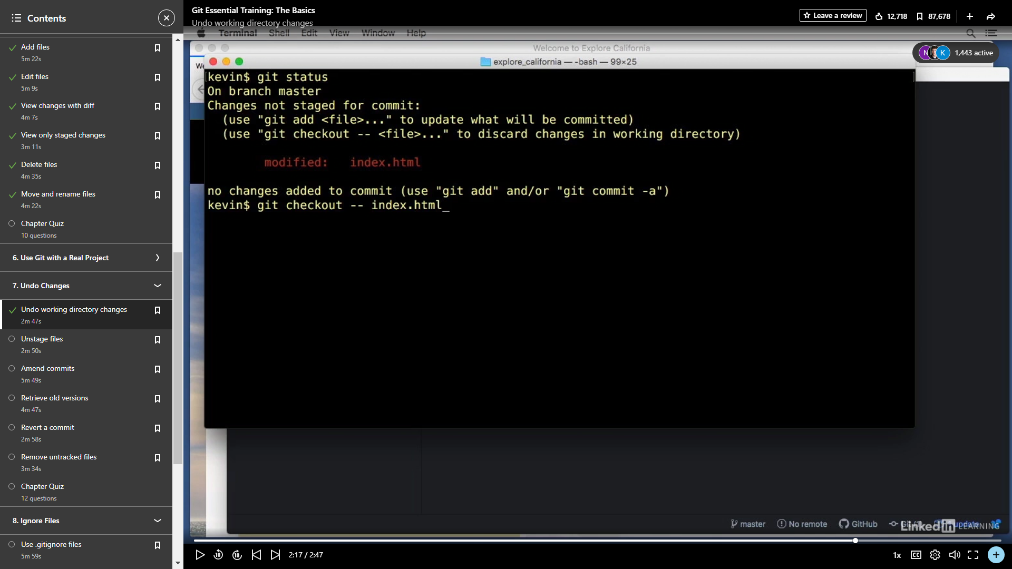

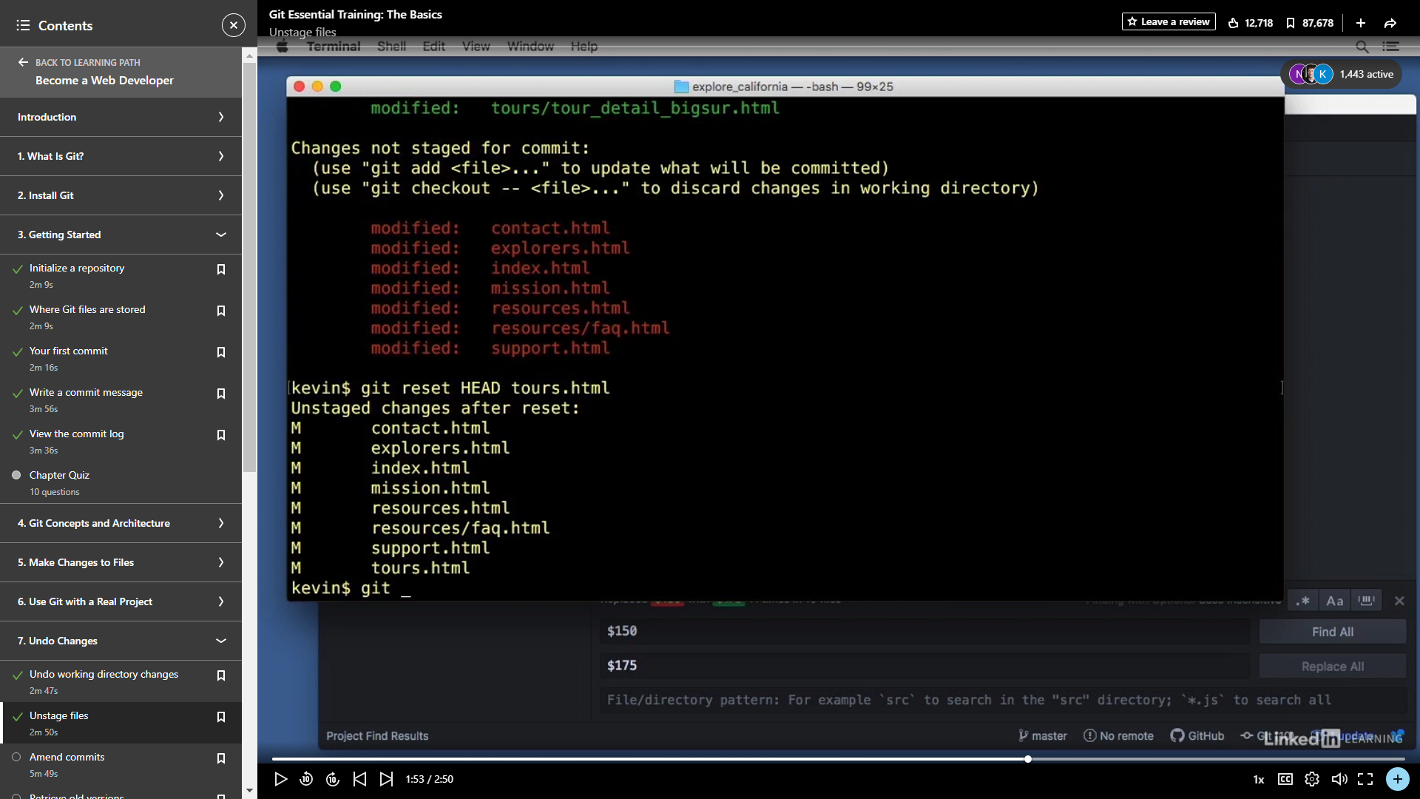

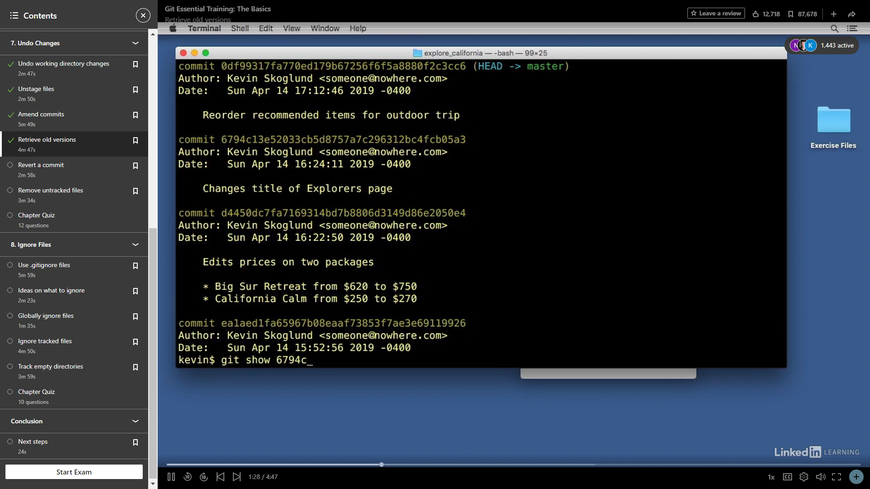

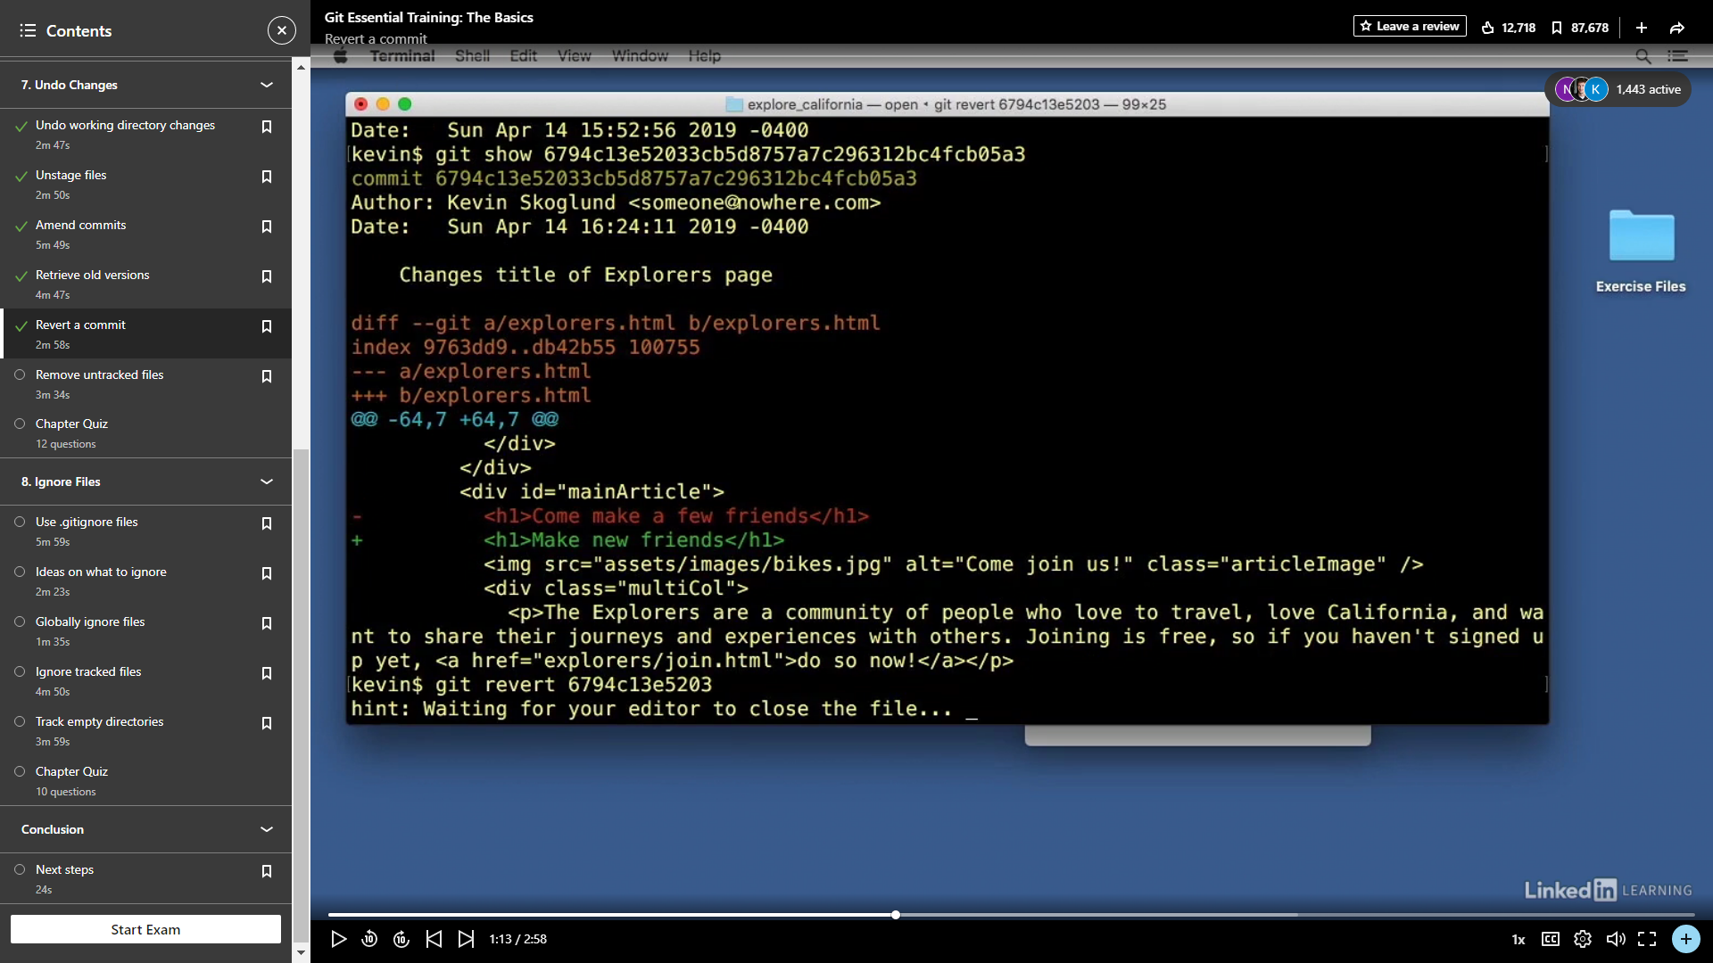

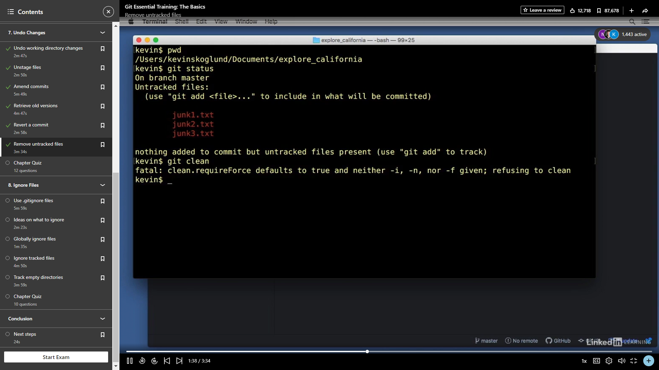

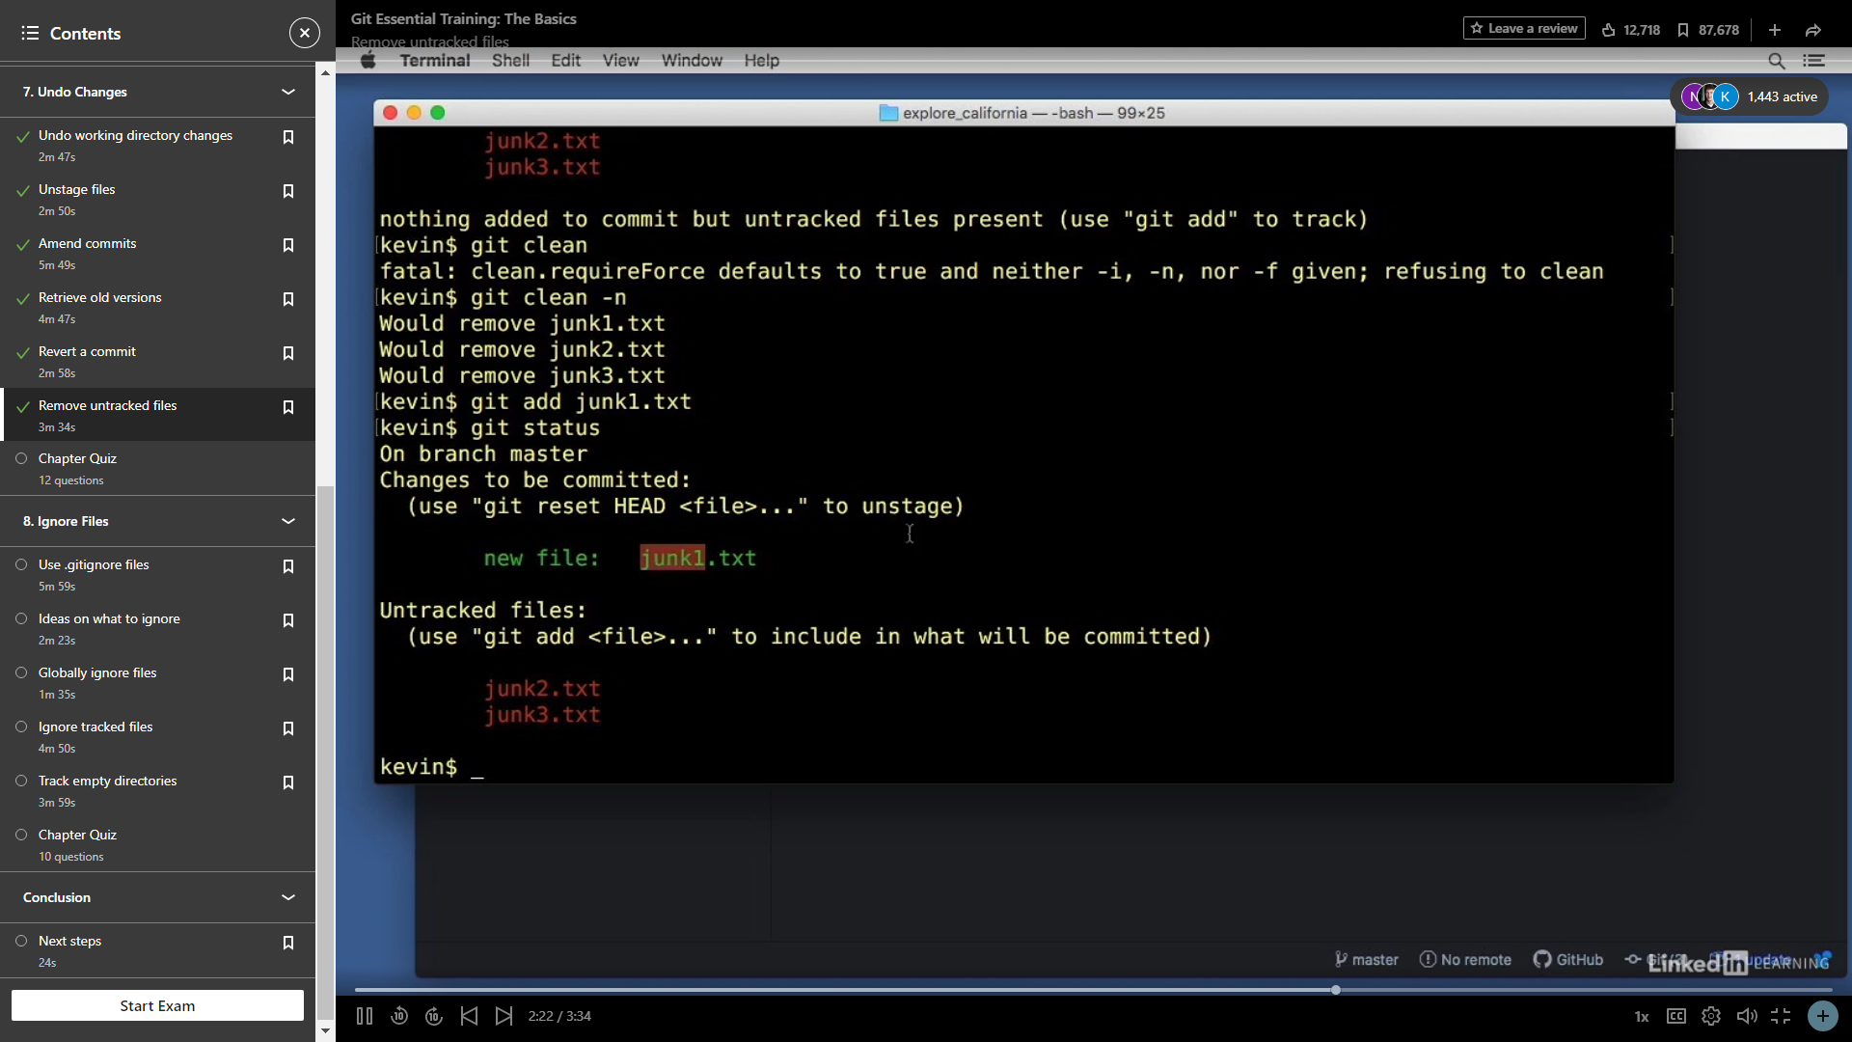

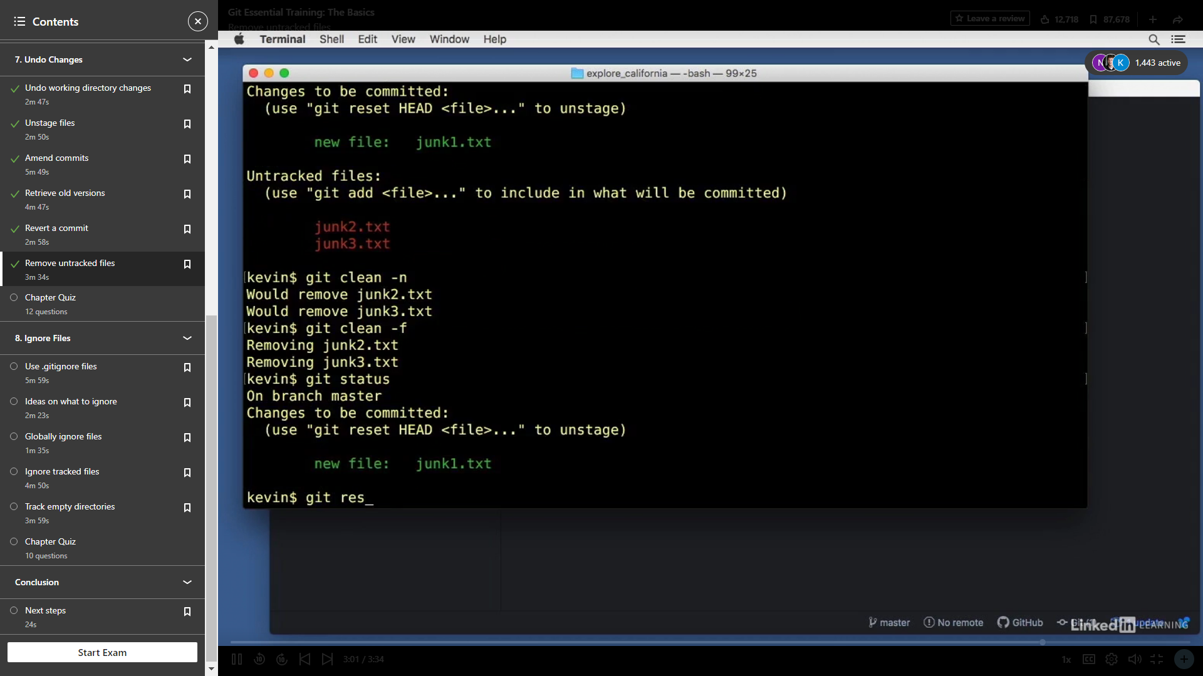

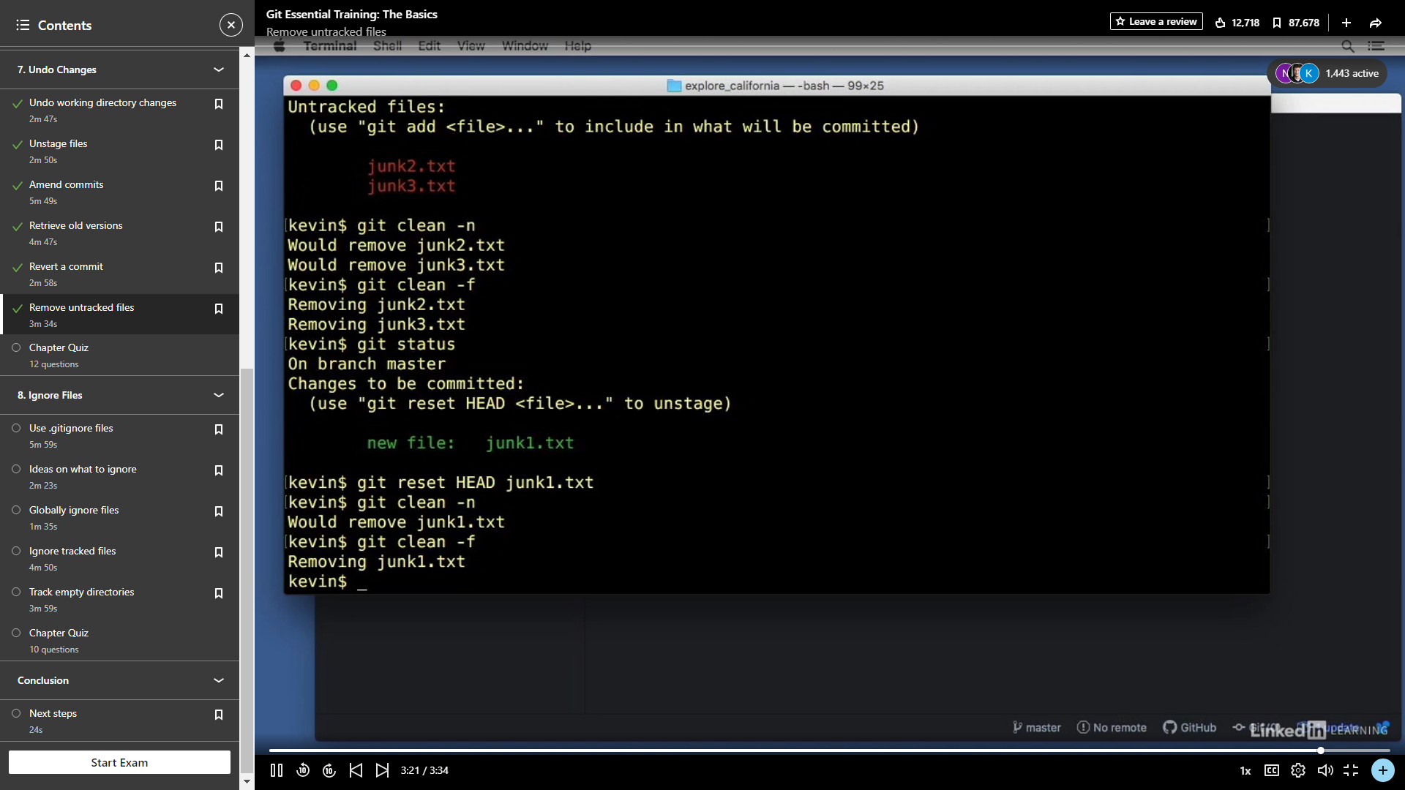

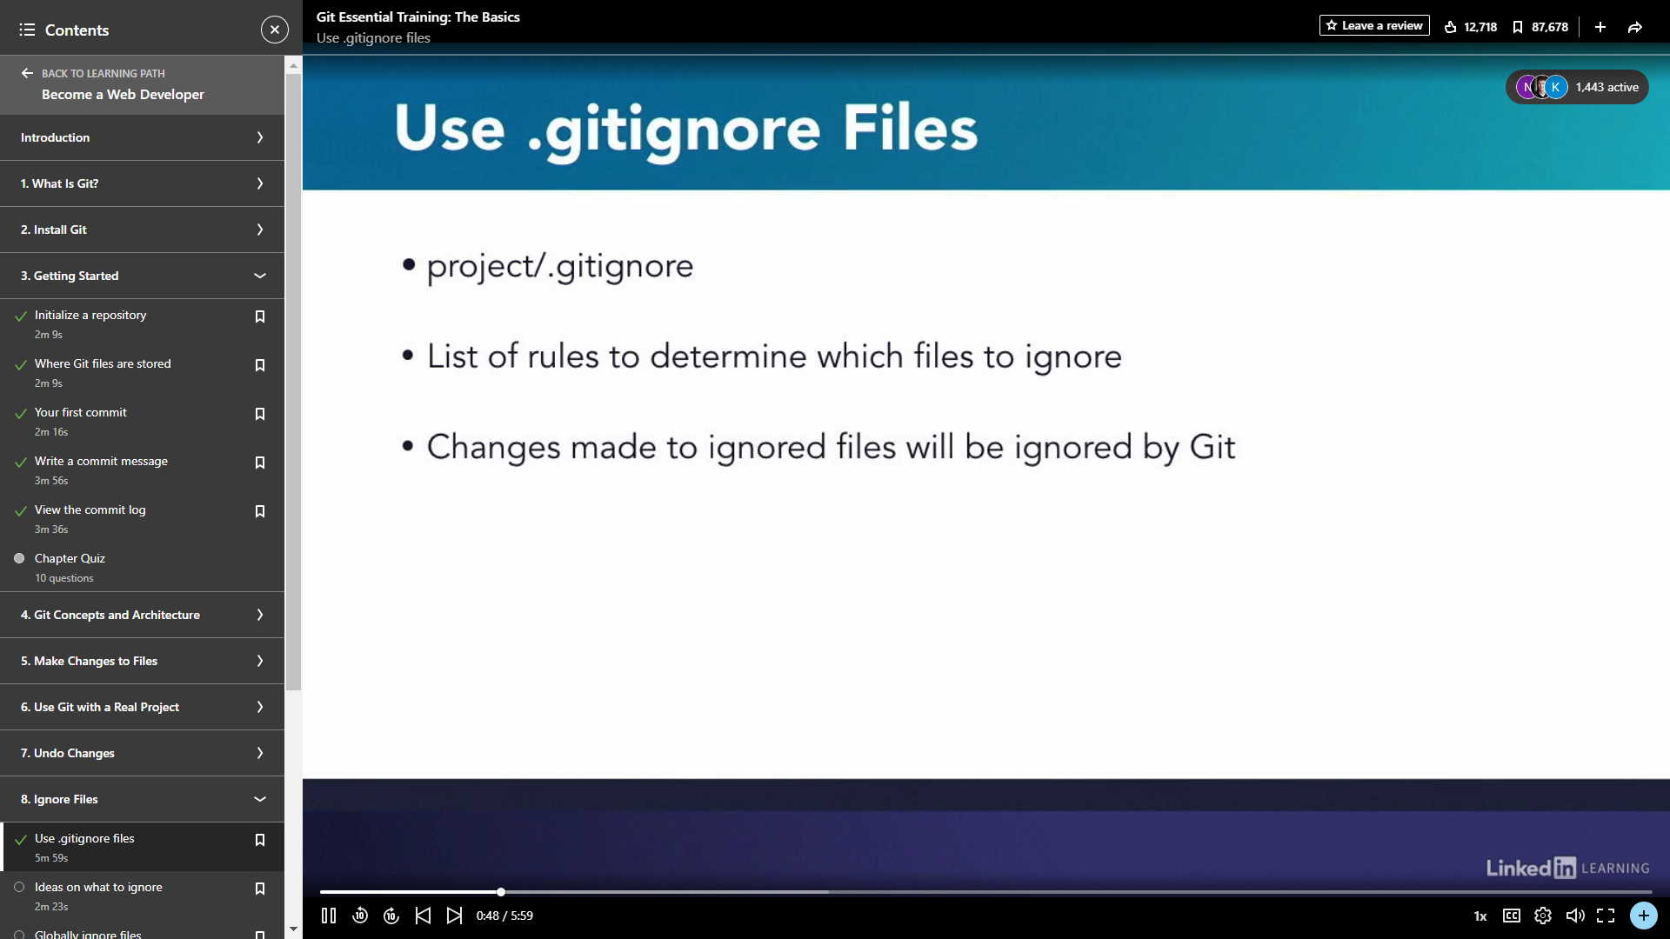

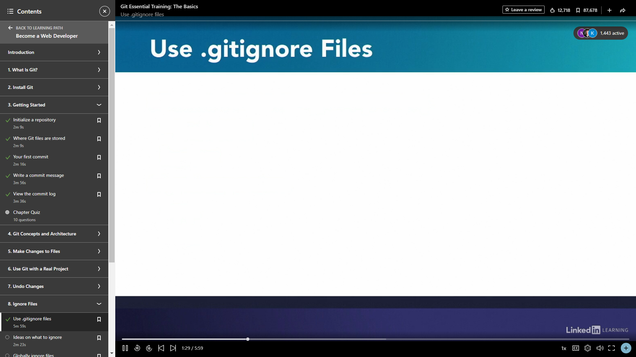

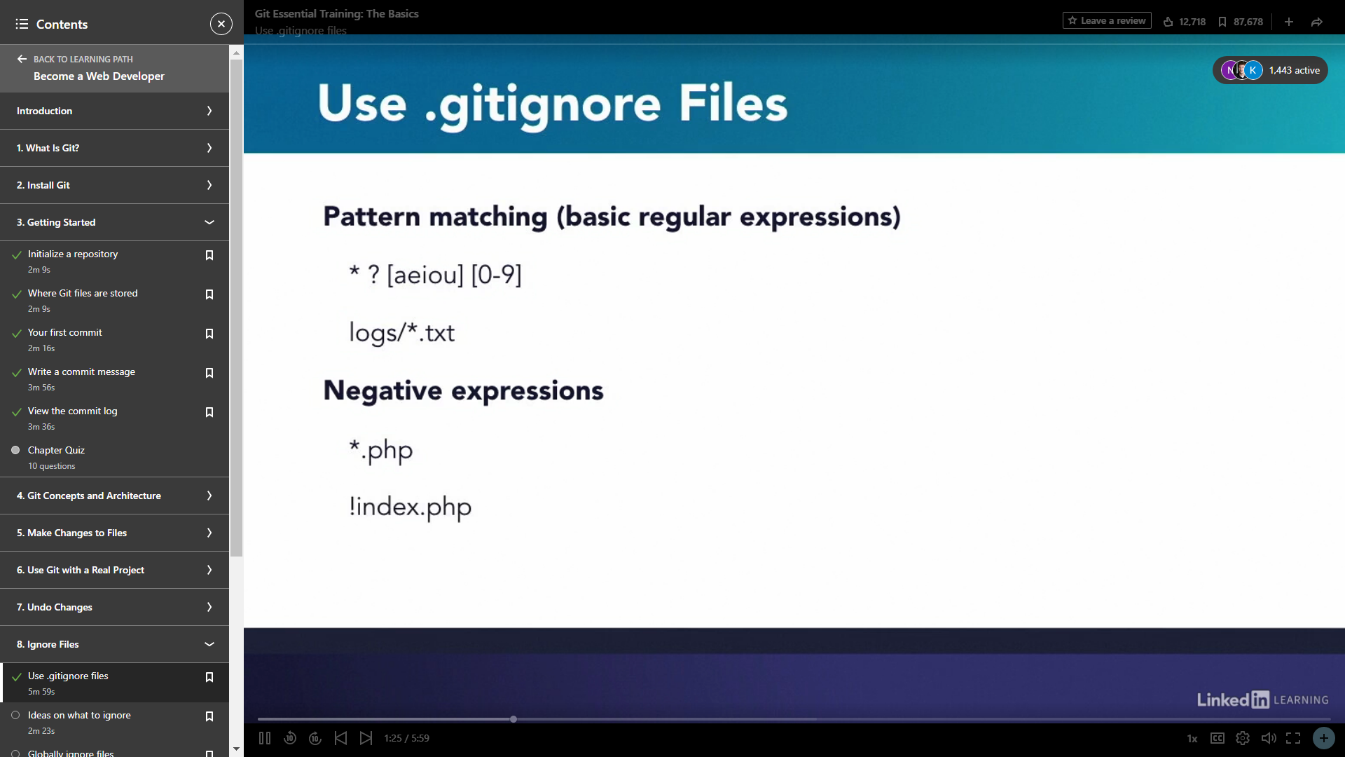

.gitIgnore Files Ignores all the files.

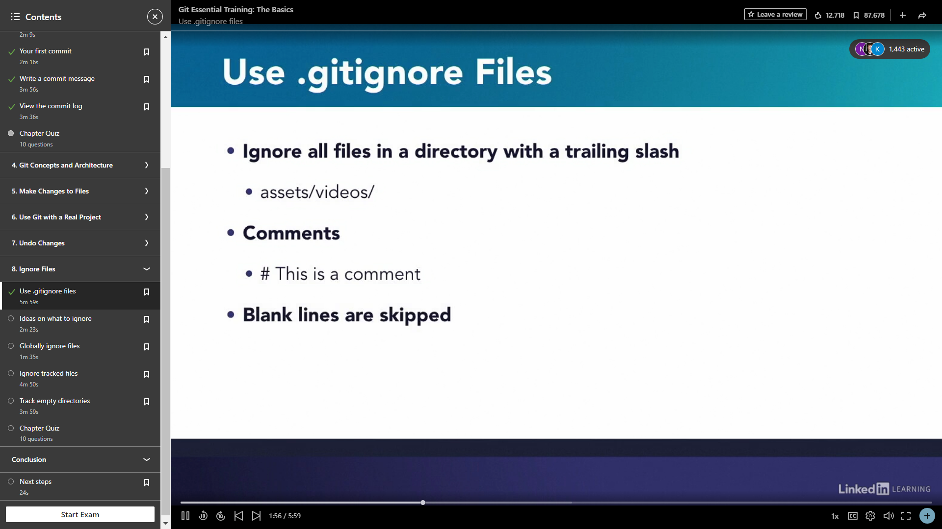

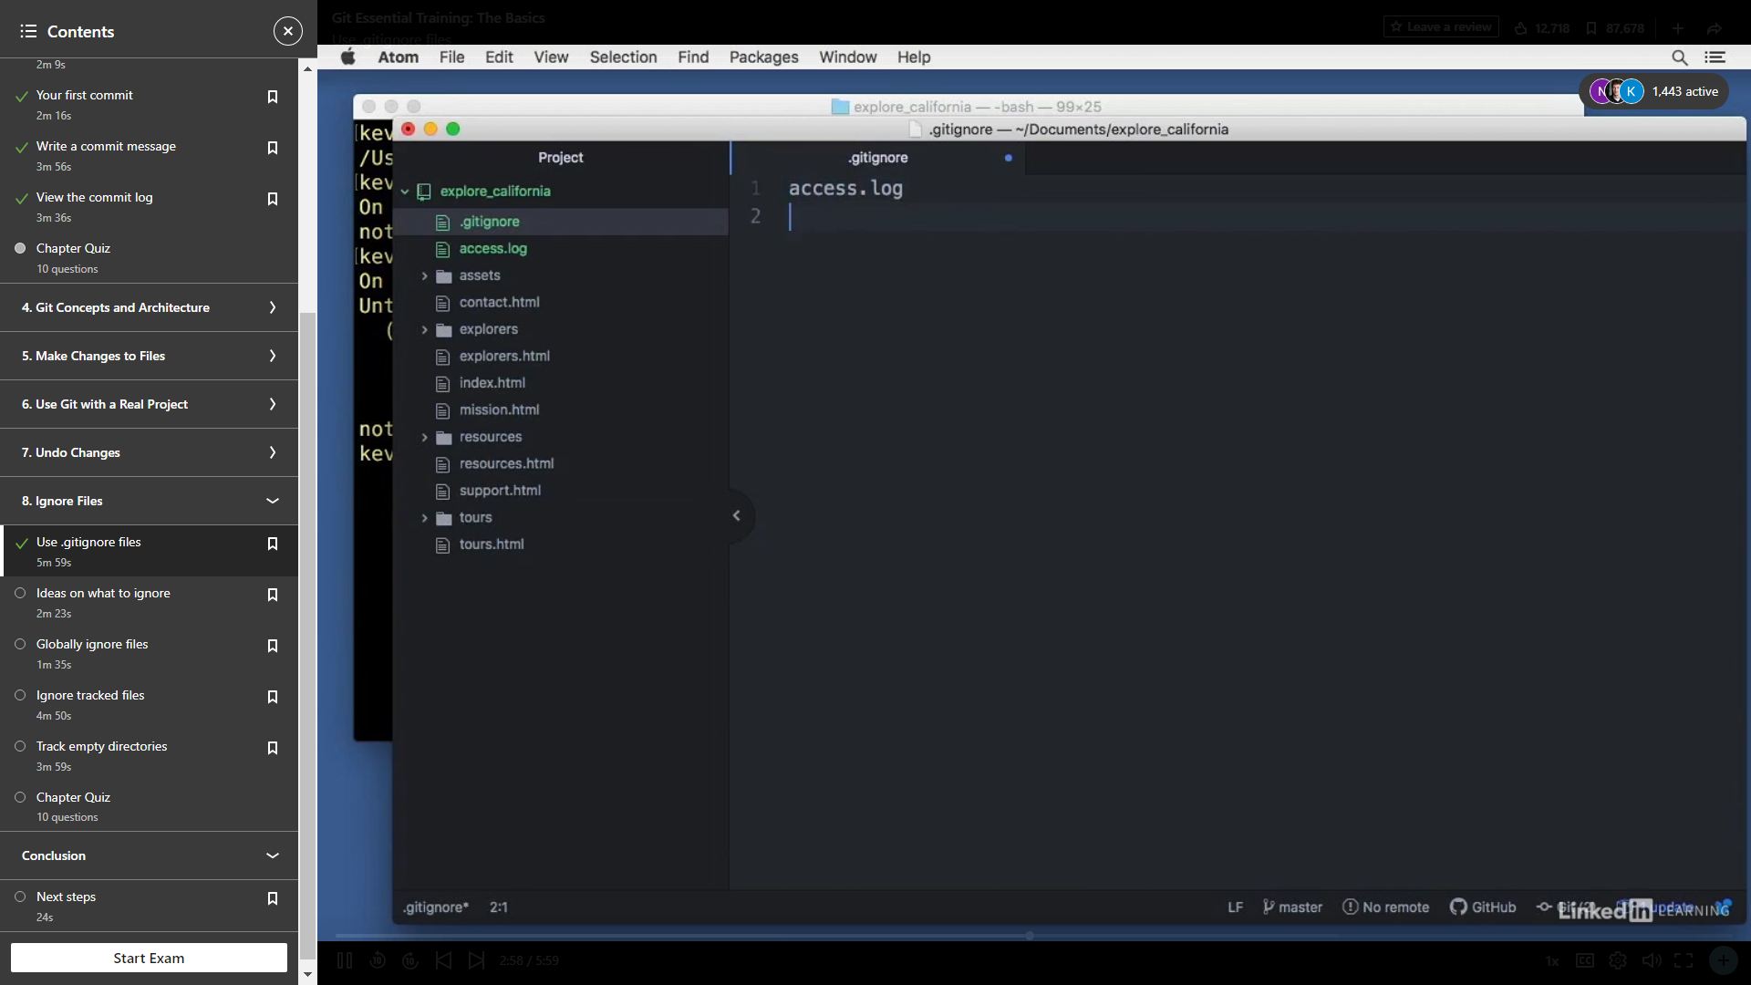

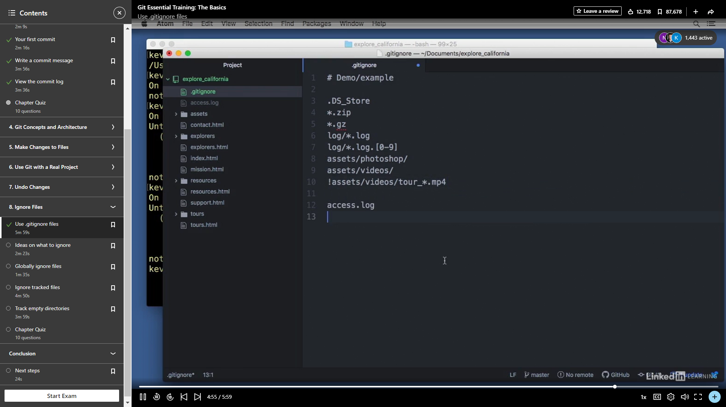

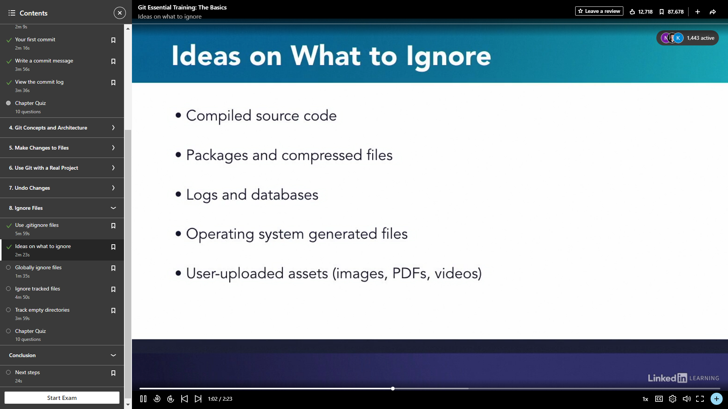

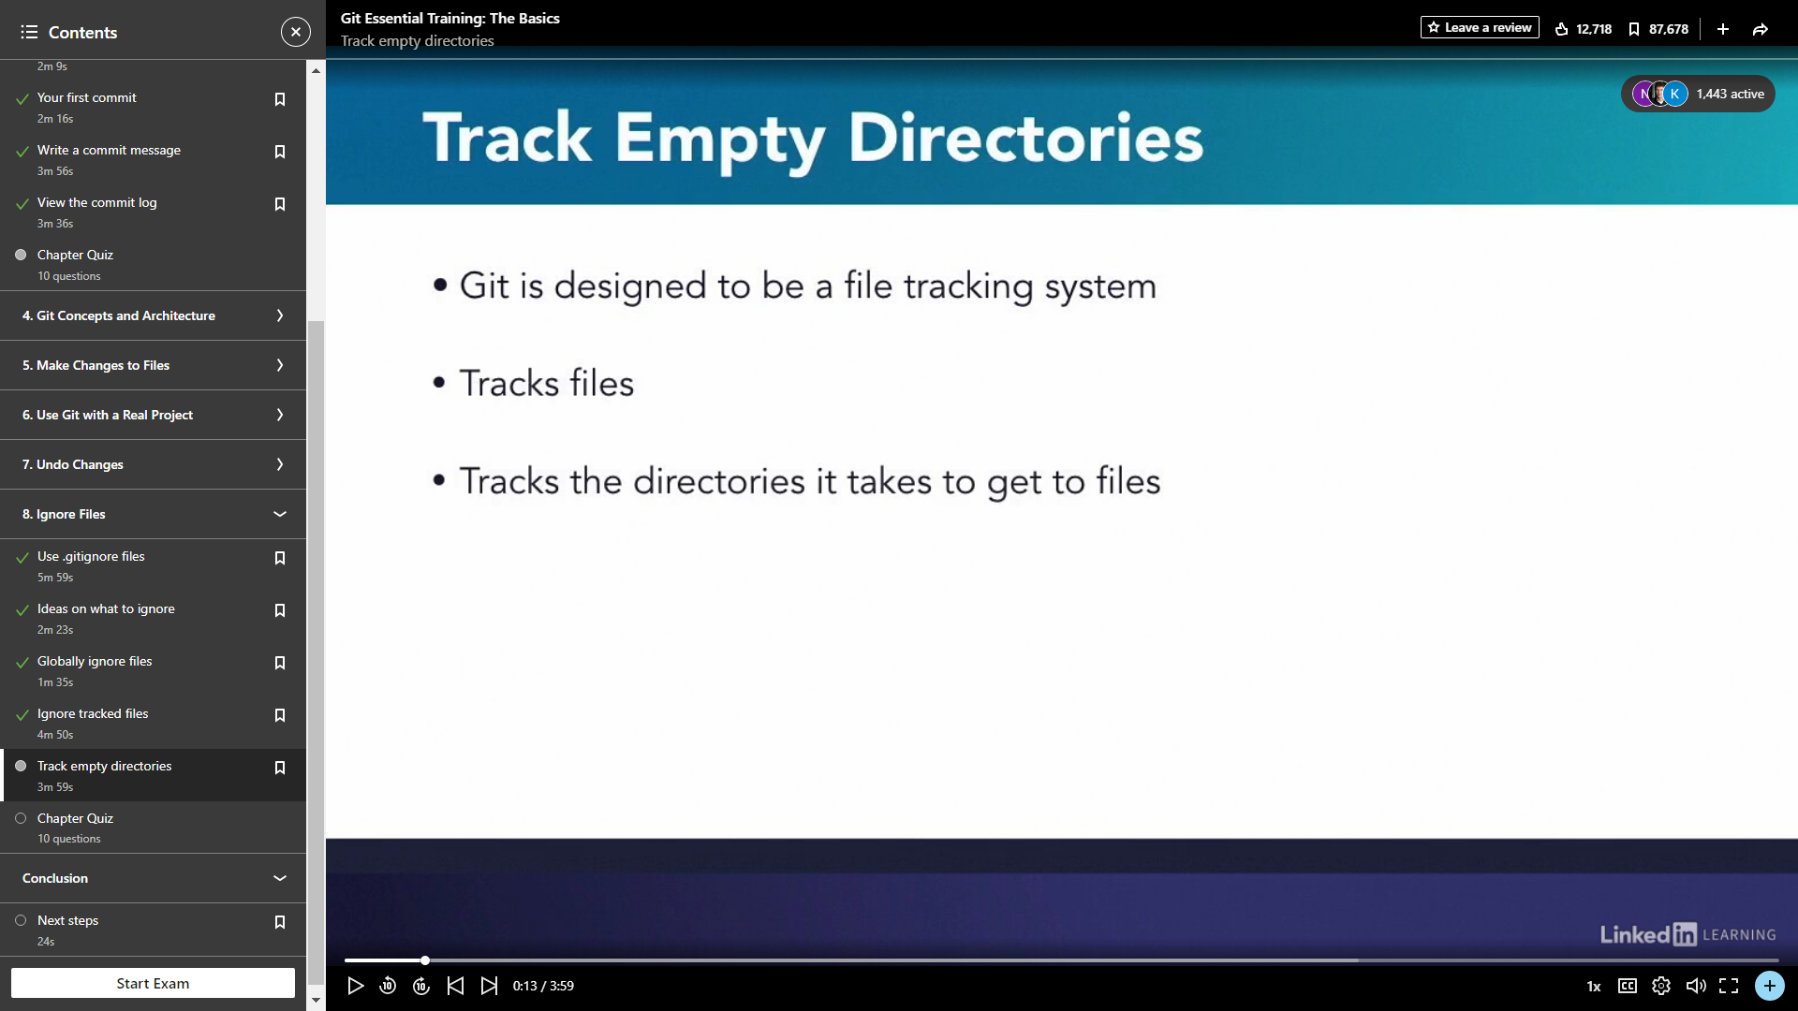

**GITHUB**

GitHub is a provider of Internet hosting for software development and version control using Git. It offers the distributed version control and source code management functionality of Git.

Ssh key→tells github to connect with pc.

1. Create Repository.

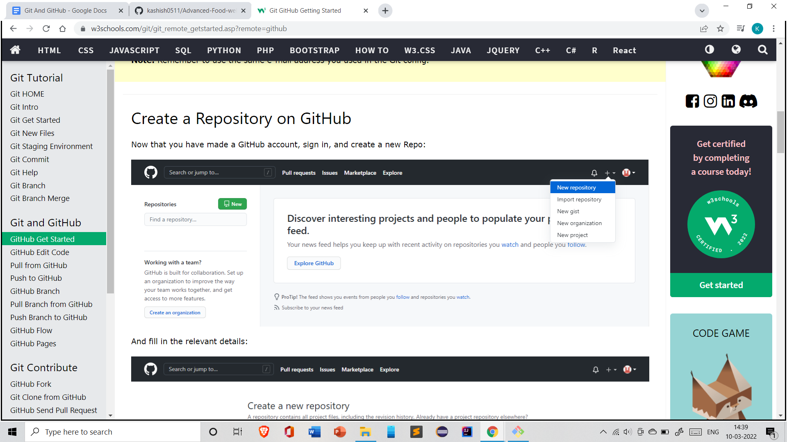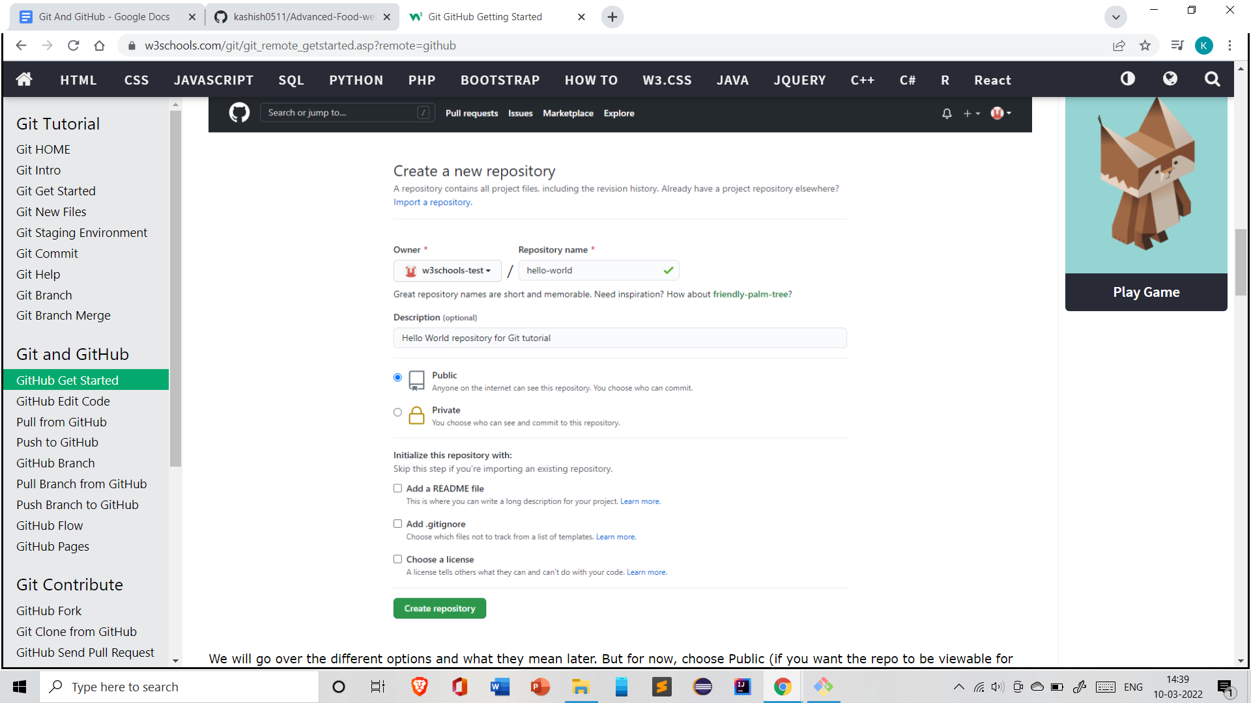

1. Git remote add origin <link>.

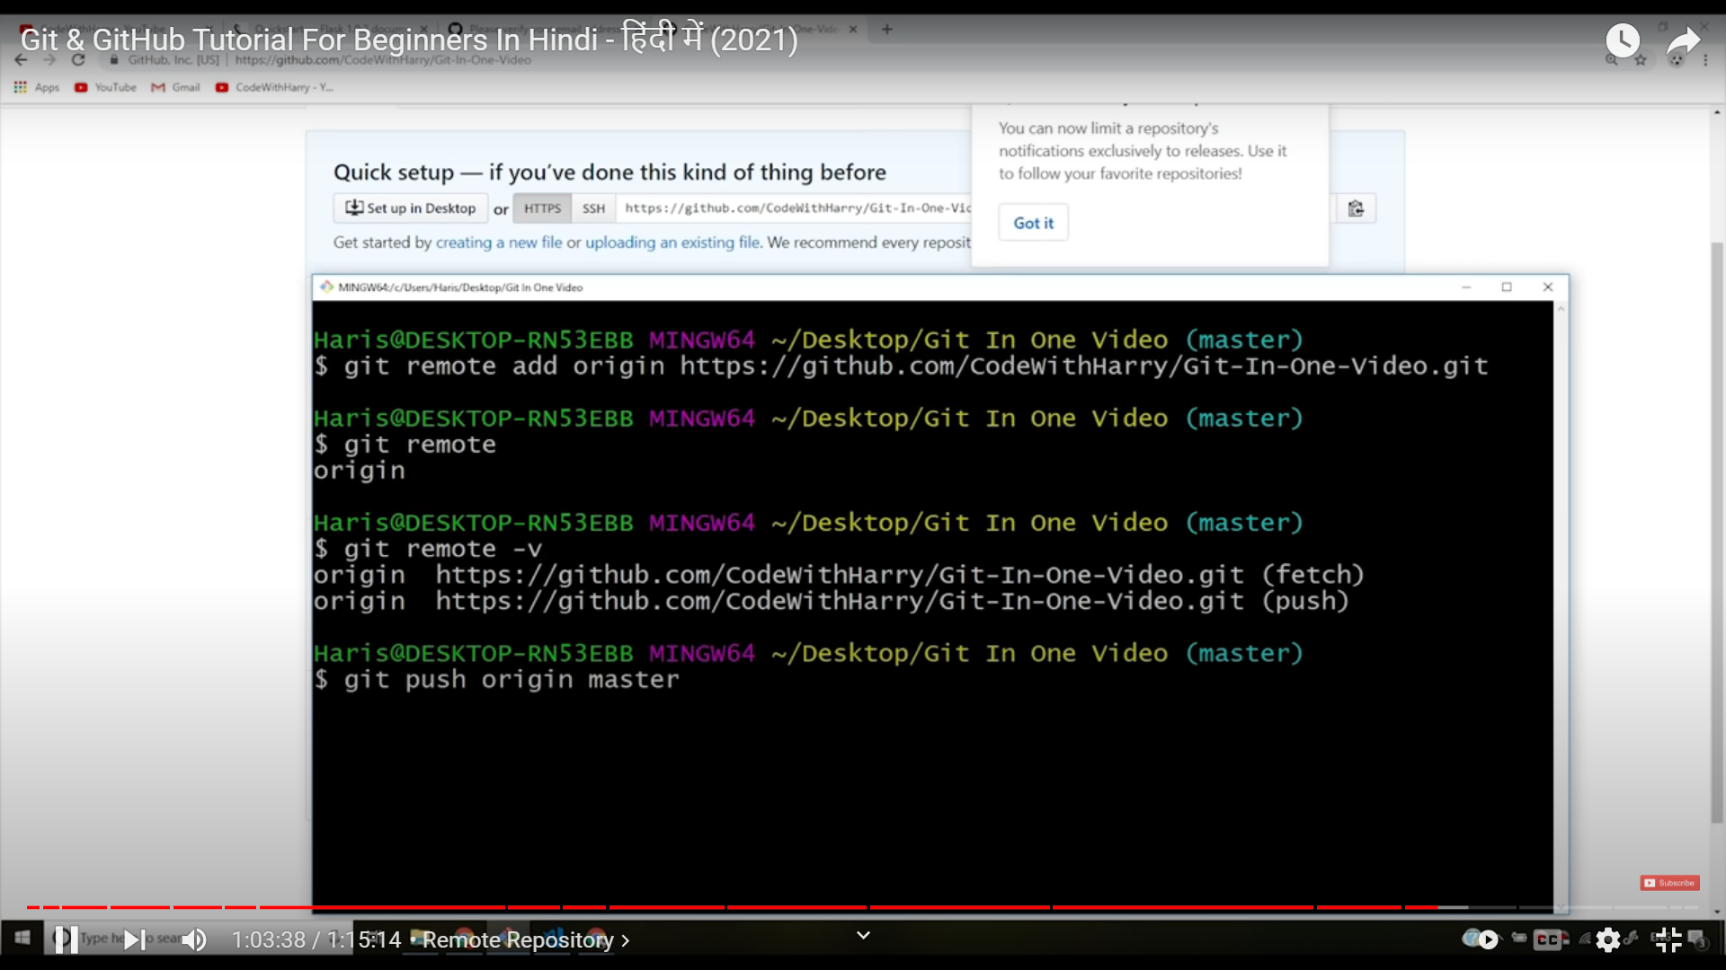

Git push -u origin master→pushes code to github.

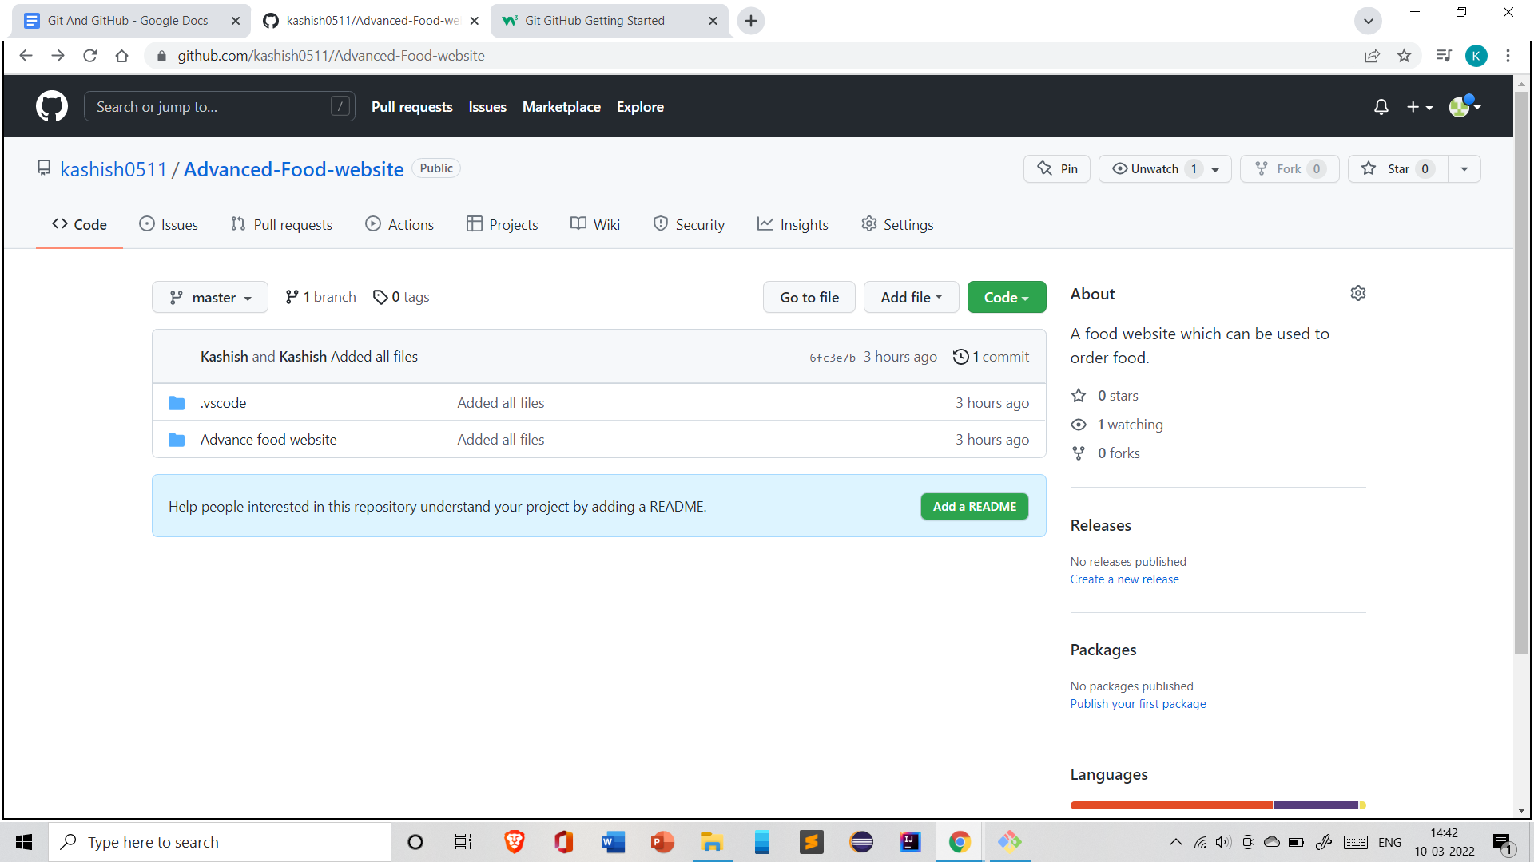

On github,we can edit ,update ,delete ,create branches,or can be modified in anyway as we want.

# Git Pull from GitHub

Pull command is a combination of 2 different commands:

fetch → git fetch

Merge → git merge origin master